Number 44 | January 2014

Summary | This newsletter describes recent enhancements to the National Student Loan Data System (NSLDS) and the NSLDS Professional Access Web site. They include:  - Enhancements to Support the 150% Direct Subsidized Loan Limit  - New Consolidation Loan Type – ‘D9’  - Discontinue ‘D0’ to ‘D1’ Loan Type Conversion to the Central Processing System (CPS) for the 2014-2015 Award Year  - Display of Subsidized Usage Limit Applies (SULA) Informational Flag  - Updates to 2014-2015 Prescreening and Postscreening Processes  - Delay of Updated Transfer Student Monitoring (TSM) and Financial Aid History (FAH) Process and Batch File Layouts  - Identifying the New Federal Perkins Servicer on NSLDS  - Updates for Total and Permanent Disability
Enhancements to Support the 150% Direct Subsidized Loan Limit | New Consolidation Loan Type – ‘D9’  With the implementation of the 150% Direct Subsidized Loan Limit, a new loan type of ‘D9’ has been created to identify a Direct Consolidation Subsidized Loan where the 150% Direct Subsidized Usage Limit Applies (SULA) because the consolidation loan includes one or more Direct Subsidized Loans that are subject to the 150% limit.  NSLDS will treat the new ‘D9’ loan type similar to the existing ‘D6’ (Direct Consolidated Subsidized) loan type. On the NSLDS Professional Access Web site, the new ‘D9’ loan type will display on any Web page where loan types are viewed. Like the existing ‘D6’ loan type, the ‘D9’ loan type will be used in the calculation of annual and maximum aggregates for subsidized loans.  Discontinue Conversion of ‘D0’ Loan Type for CPS  As a reminder, because the CPS was not ready to accept the new ‘D0’ (Direct Stafford Subsidized, SULA Eligible) loan type from NSLDS until the beginning of the 2014-2015 Award Year, NSLDS converted the ‘D0’ loan type to a ‘D1’ (Direct Stafford Subsidized) loan type when providing loan information to CPS for the 2013-2014 Award Year. This meant that some ‘D1’ loan types on CPS outputs during 2013-2014 were actually ‘D0’ loan types.  For 2014-2015, NSLDS has stopped the conversion of the ‘D0’ to ‘D1’ loan type and sends the ‘D0’ loan type when providing loan information to CPS. Additionally, all NSLDS 2014-2015 Student Eligibility related outputs (Transfer Student Monitoring/Financial Aid History Batch Inform Files) will contain the actual loan types.  Display of SULA Informational Flag  The NSLDS Professional Access Web site now displays on the Loan History, Grant History, Overpayment History, Overpayment List, and Student Access Interface pages the following new informational flag for borrowers who are subject to the 150% Direct Subsidized Loan Limit provision:  Note: Only first-time borrowers on or after July 1, 2013 are subject to the new provision. Generally, a first-time borrower is one who did not have an outstanding principal or interest balance on a Direct or Federal Family Education Loan (FFEL) Program loan on July 1, 2013.  2014-2015 Prescreening Process  New for the 2014-2015 Award Year is the inclusion of the SULA Flag and Subsidized Loan Eligibility Used fields in the prescreening process.  The SULA Flag indicates whether the borrower is subject to the 150% Direct Subsidized Loan Limit provision. The SULA Flag field will have the following values:  - Y = The borrower is subject to the 150% Direct Subsidized Loan Limit provision.  - N = The borrower is not subject to the 150% Direct Subsidized Loan Limit provision.  The Subsidized Loan Eligibility Used field displays the total Subsidized Usage Period for the student, as reported to NSLDS by the Common Origination and Disbursement (COD) System. See the 150% Direct Subsidized Loan Limit – Frequently Asked Questions page on the Information for Financial Aid Professionals (IFAP) Web site for information on Subsidized Usages Periods. This field contains numeric six-digit values, 000v000 to 999v999, where “v” is an implied decimal and is excluded from the output.  Note: Consistent with the information provided in the 150% Frequently Asked Questions, the total does not include time during which the student received Direct Subsidized Loans while enrolled in a non-credential teacher certification program.  2014-2015 Postscreening Process  The following Postscreening Reason Code has been added to the 2014-2015 postscreening process to alert schools when there is a change to a student’s SULA flag:  - ‘25’ = Subsidized Usage Limit Applies Flag status change  Delay of Updated TSM/FAH Process and Batch File Layouts  As described in a November 19, 2013 Electronic Announcement, the annual posting of updated NSLDS Transfer Student Monitoring (TSM) and Financial Aid History (FAH) Process and Batch File Layouts will be delayed until Spring 2014. This postponement will allow for incorporation of changes related to the 150% limit for Direct Subsidized Loans.  Please continue to use the current NSLDS TSM and FAH Process and Batch File Layouts, posted on November 16, 2012 and monitor the IFAP Web site for the posting of updated layouts.
Identifying the New Federal Perkins Servicer on NSLDS | The Department has established a new Federal Perkins Loan Servicer to receive, manage, and collect on Federal Perkins Loans assigned to the Department of Education.  The Federal Perkins Loan Servicer is identified in NSLDS as:  Name: DEPT OF ED/ECSI FEDERAL PERKINS SERVICER  Code: 529  Loans serviced by the ECSI Federal Perkins Loan Servicer display as the ED Servicer on the Loan History page under the Aid tab of the NSLDS Professional Access Web site. Additionally, the servicer displays on the Loan Detail page under Guaranty Agency/Lender/Servicer Agent History section.  Loan History:  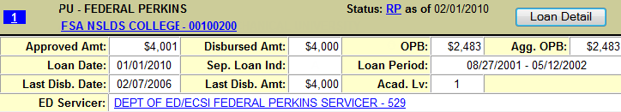  Loan Detail:  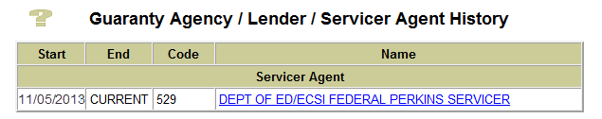  The contact information associated with this code displays on the Org Contact List:  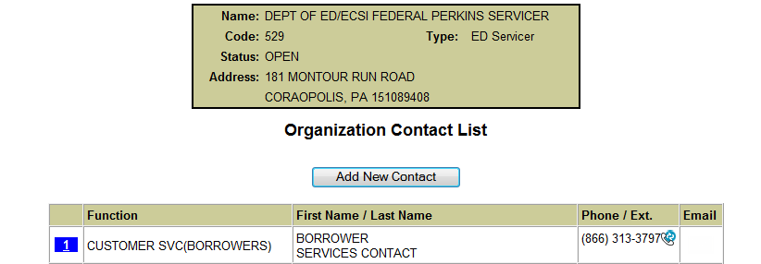
Updates for Total and Permanent Disability | With the implementation of the new total and permanent disability (TPD) discharge regulations, we have made the following changes to the 2014-2015 NSLDS prescreening and postscreening processes:  - For prescreening, loans with the status of ‘PD’ (Permanent Disability) will display the ‘Contact Type’ of ‘DDP’ (Disability Data Provider) and ‘Contact’ of the Nelnet Total and Permanent Disability Servicer, code ‘582’,  - Postscreening Reason Code ‘06’ will be generated when a loan goes into a ‘PD’ loan status, and  - Postscreening Reason Code ‘07’ will be generated when a loan comes out of a ‘PD’ loan status.
Customer Service Reminder | Please remember to keep your NSLDS Professional Access Web site ORG contacts current and always list at least a Primary Contact for your organization.  The NSLDS Customer Support Center at 800/999-8219 is available Monday through Friday from 8 A.M. to 9 P.M. (ET). You may also contact Customer Support by e-mail at nslds@ed.gov. Callers in locations without access to 800 numbers may call 785/838-2141.

