
Number 43 | July 2013

Summary | This newsletter describes enhancements to the National Student Loan Data System (NSLDS) and the NSLDS Professional Access Web site. These enhancements include:  - Enhancements to Support the 150% Direct Subsidized Loan Limit  - New Loan Type – ‘D0’  - Conversion of the ‘D0’ Loan Type for the Central Processing System (CPS)  - Updates to the School Portfolio Report (SCHPR1)  - New Income Driven Repayment Plan Type Code  - Updates to Enrollment Reporting  - New “Moved” Enrollment Status  - Display of “Moved” Enrollment Status  - “Moved” Enrollment Status Outputs  - Enrollment Push to Roster for Schools  - Enhancements to Exit Counseling  - New and Updated Fields on the Exit Counseling Submittal Template  - New Source Type on the Exit Counseling History Page
Enhancements to Support the 150% Direct Subsidized Loan Limit | New Loan Type – ‘D0’  With the implementation of the 150% Direct Subsidized Loan Limit, a new loan type of ‘D0’ has been created to identify a Direct Subsidized Loan where the new 150% Direct Subsidized Usage Limit Applies (SULA).  NSLDS will treat the new ‘D0’ loan type similar to the existing ‘D1’ (Direct Stafford Subsidized) loan type. On the NSLDS Professional Access Web site, the new ‘D0’ loan type will display on any Web page where loan types are viewed. The ‘D0” loan type will be included in the calculation of annual and maximum aggregates for subsidized loans.  Important information regarding the 150% Direct Subsidized Loan Limit is available on the Information for Financial Aid Professionals (IFAP) Web site.  Conversion of the ‘D0’ Loan Type for the Central Processing System (CPS)  The Central Processing System (CPS) will not be ready to accept the ‘D0’ loan type from NSLDS until it begins processing 2014-2015 FAFSAs in January 2014. Therefore, to maintain continuity in the output of CPS information for the entire 2013-2014 FAFSA processing year, NSLDS will convert the ‘D0’ loan type to a ‘D1’ loan type when transferring loan information to the CPS. This means that some ‘D1’ loan types on CPS outputs during this timeframe will actually be ‘D0’ loan types.  Similarly, to maintain continuity with the information presented on 2013-2014 SARs and ISIRs, all NSLDS 2013-2014 student eligibility related outputs (Transfer Student Monitoring and Financial Aid History) will include the converted (‘D0’ to ‘D1’) loan type.  For the 2014-2015 FAFSA processing year, the CPS will implement the ‘D0’ loan type and NSLDS will not convert ‘D0’ to ‘D1’ for 2014-2015 CPS outputs. Further information on this change will be described in an upcoming Newsletter.  Until the new loan type is fully implemented in the CPS, the NSLDS system is the system of record and schools should reference NSLDS to determine which of a borrower’s loans are subject to the new 150% Direct Subsidized Loan Limit requirement.  Updates to the School Portfolio Report (SCHPR1)  The School Portfolio Report (SCHPR1) has been updated to include the new Subsidized Usage Limit Applies (SULA) Flag field. The new SULA Flag indicates whether the borrower is subject to the 150% Direct Subsidized Loan Limit provision. This field will appear on loan records when reported by the federal loan servicer and is used to track SULA eligibility at a borrower level. The SULA Flag field will have the following values:  - Y = The borrower is subject to the 150% Direct Subsidized Loan Limit provision.  - N = The borrower is not subject to the 150% Direct Subsidized Loan Limit provision.  - Blank = Not reported by loan servicer or not applicable.  Additionally, the new ‘D0’ loan type has been added to the report output as an option for the Loan Type field.  The updated record layouts for both the fixed-width and comma separated values (CSV) versions of the School Portfolio Report are available in the NSLDS Record Layouts section of the IFAP Web site.
New Income Driven Repayment Plan Type Code | In NSLDS Newsletter 42, posted to the IFAP Web site on February 27, 2013, new Repayment Plan Type codes were announced to provide a more detailed explanation of the Repayment Plan under which a borrower is repaying a loan. As of June 16, 2013, the following Repayment Plan Type code was added to NSLDS:  - P1 – Pay As You Earn – No Partial Financial Hardship  The new code is for borrowers who are on the Pay As You Earn (PA) repayment plan but no longer have a partial financial hardship.  Note: Repayment Plan Type codes are only reported for Direct Loans and FFEL Loans that are owned by the Department.  The Delinquent Borrower Report (DELQ01) and the School Portfolio Report (SCHPR1) were updated to include the new ‘P1’ Repayment Plan Type code. The updated extract file layouts are available in the NSLDS Record Layout section of the IFAP Web site.
Updates to Enrollment Reporting | New “Moved” Enrollment Status  In NSLDS Newsletter 39, posted to the IFAP Web site on July 6, 2012, we introduced the “Move To” functionality, which allows schools to more easily report that a student is attending a different location code of the school. Schools which share the same first 6-digits of an OPEID, along with the same Enrollment Administrator, can use the “Move To” function to update the student’s enrollment record. NSLDS has enhanced this feature by creating a “Moved” enrollment status to differentiate the reporting of this change from that of a student’s withdrawal.  Previously, NSLDS displayed the enrollment status for the prior school location as “Withdrawn” and stored the enrollment status code of “W”. NSLDS is now displaying a status of “Moved” and storing the enrollment status code as an “M” to better represent the intention of the reported record.  Reporting a “Move To” ensures that the appropriate 2-digit location code is listed for the student’s attendance. Schools can use this functionality to report a transfer from one location to another, or to correct a misreported location code.  This enhancement does not require a school or their software provider to program for a new enrollment status code. NSLDS adds the student to the roster of the new location code and ends the enrollment at the reporting location, thus an “M” enrollment status will not appear on enrollment rosters for either location. Additionally, NSLDS does not require a second certification from the reporting location to remove the student from their roster.  Display of “Moved” Enrollment Status  After the “Move To” location change has been successfully reported by the school, the NSLDS Professional Access Web site displays the “Moved” enrollment status for the record of the prior school on the following enrollment Web pages:  - Enrollment Summary  - Enrollment Detail  - Enrollment Timeline  The examples below demonstrate a “Move To” reporting:  Enrollment Summary page:  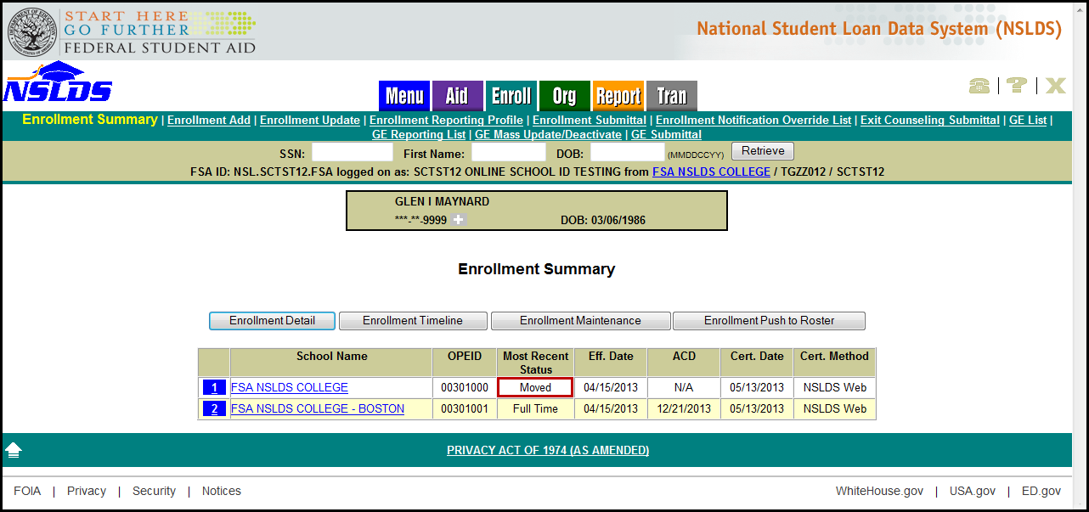  Enrollment Detail page:  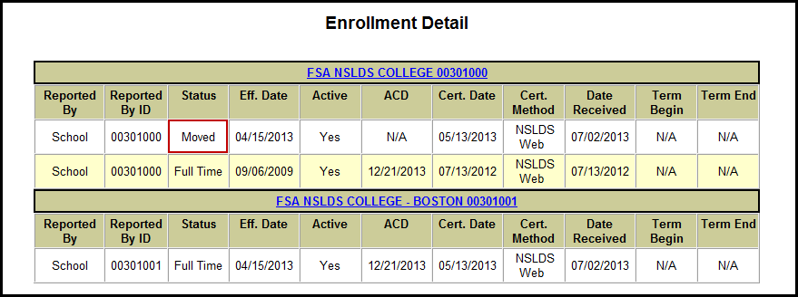  Enrollment Timeline page:  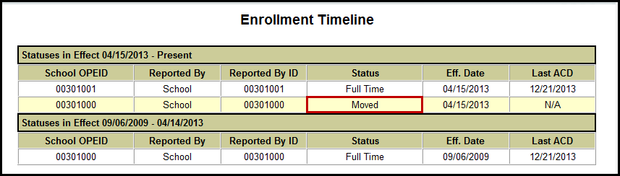  NSLDS has also added a row in the Enrollment Certification by Quarter page to display the count of records a school reported using the “Move To” functionality:  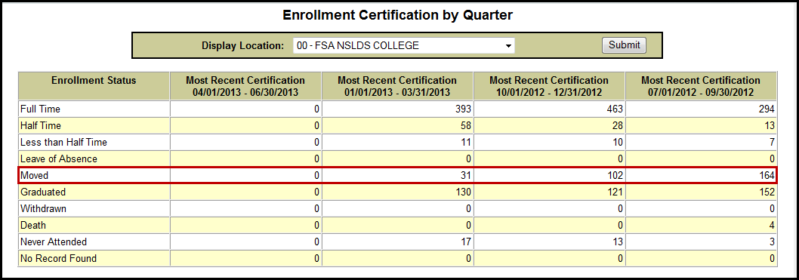  “Moved” Enrollment Status Outputs  NSLDS will convert an enrollment code of “M” to “W” when including records in the NSLDS Enrollment Notification File, which provides the weekly certified enrollment records to loan holders. Along with any inactive enrollment status (L, G, W, X, or Z) record, NSLDS also provides certified active “alternate attending” enrollment data. Therefore, any moved record will be reported to the loan holder with both the inactive and active enrollment information.  NSLDS will also convert the enrollment status from an “M” to a “W” before executing any processes that utilize enrollment data calculations, including Cohort Default Rate calculations. These processes and their outputs will not be impacted by the conversion.  Additionally, all scheduled and on-demand reports that contain enrollment status will continue to use the enrollment status of “W” in place of the “M”.  Enrollment Push to Roster for Schools  Schools that do not share the same 6-digit OPEID and Enrollment Administrator may use the “Enrollment Push to Roster” option to add a student to the roster of another institution. On the Enrollment Summary Web page, the Enrollment Push to Roster button opens a new page on which schools may enter the 8-digit OPEID of the institution that will need to certify the student’s enrollment. Once the request is submitted, NSLDS adds the student to the next roster of the indicated school.  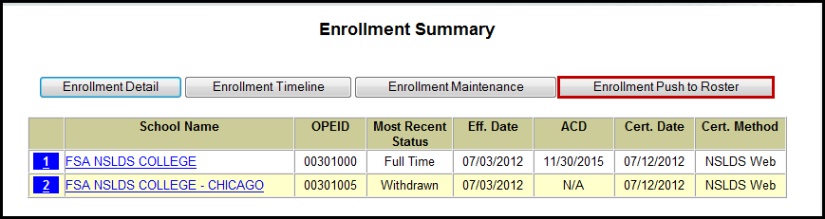  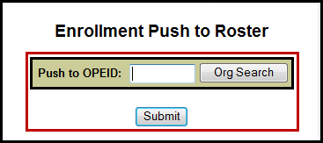  After clicking the Submit button, a message appears that the student was successfully added.
Enhancements to Exit Counseling | New and Updated Fields on the Exit Counseling Submittal Template  The Exit Counseling Submittal Template has been enhanced to include new data fields. Columns have been added to allow for the reporting of foreign addresses for Next of Kin and References. These new fields are:  - Next of Kin Country  - Reference 1 Country  - Reference 2 Country  In addition to the new fields, the field lengths of Zip Code and Phone Number for Next of Kin, Reference 1, and Reference 2 have been expanded to allow for the reporting of foreign addresses and phone numbers.  The updated Exit Counseling Submittal Template and its associated documents can be downloaded from the Software and Associated Documents section of the FSAdownload Web site.  New Source Type on the Exit Counseling History Page  For Loan Exit Counseling records completed on the StudentLoans.gov Web site and transmitted to NSLDS, the Source type of the Loan Exit Counseling data will now display as “STUDENTLOANS.GOV” on the Exit Counseling History page of the NSLDS Professional Access Web site.  Below is an example of the new Source type displaying on the Exit Counseling History page:  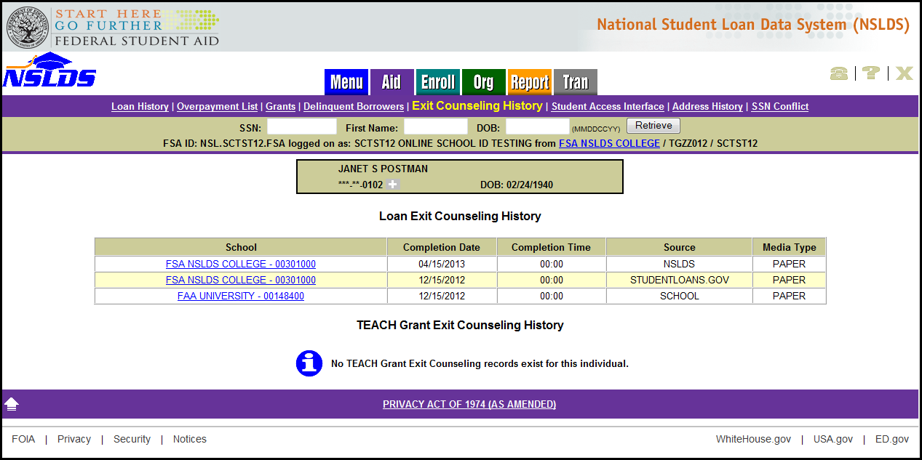  For Loan Exit Counseling records submitted to NSLDS via the Exit Counseling Submittal Template, the Source type will continue to display as “SCHOOL”. If “NSLDS” is displayed as the Source type for either Loan or TEACH Grant Exit Counseling, the counseling session was completed on the NSLDS Student Access Web site.  Note: As of March 24, 2013, Loan Exit Counseling was transferred from the NSLDS Student Access Web site to the StudentLoans.gov Web site. TEACH Grant Exit Counseling is still completed on the NSLDS Student Access Web site.  The record layouts for the ad-hoc and scheduled versions of the Loan Exit Counseling Completion Extract Report (EXTC01/EXTC05) have been updated to include the new Source type and are available in the NSLDS Record Layouts section of the IFAP Web site.
Customer Service Reminder | Please remember to keep your NSLDS Professional Access Web site ORG contacts current and always list at least a Primary Contact for your organization.  The NSLDS Customer Support Center at 800/999-8219 is available Monday through Friday from 8 A.M. to 9 P.M. (ET). You may also contact Customer Support by e-mail at nslds@ed.gov. Callers in locations without access to 800 numbers may call 785/838-2141.

