National Student Loan Data System

User Guide for Transfer Student Monitoring on the Web

June 2007

Contents

1.0 Introduction 1
2.0 School Transfer Profile 3
2.1 School Transfer Profile Add 3
2.2 School Transfer Profile 5
2.3 School Transfer Profile Update 7
3.0 Student Monitoring 9
3.1 Student Monitoring Add 9
3.1.1 Loan History 10
3.1.2 Grants 12
3.2 Transfer Monitoring List 14
3.3 Student Monitoring Detail 16
3.4 Student Monitoring Update 17
3.5 Student Monitoring Delete 18
4.0 Monitoring Alert 20
4.1 Monitoring Alert Review 20
4.2 Loan Alert Display 22
4.3 Grant Alert Display 25
5.0 Additional Information 27
5.1 Transfer Monitoring Summary Report 27
5.2 Organization Contact 29

Figures

Figure 1–1, NSLDS FAP Menu Page 2

Figure 2–1, School Transfer Profile Add Page 5
Figure 2–2, School Transfer Profile Page 7
Figure 2–3, School Transfer Profile Update Page 8

Figure 3–1, Student Monitoring Add Page 10
Figure 3–2, Loan History Page—Add Student to Monitoring List Button 11
Figure 3–3, Loan History Page—Student Monitoring Detail Button 12
Figure 3–4, Grant History Page—Add Student to Monitoring List Button 13
Figure 3–5, Grant History Page—Student Monitoring Detail Button 13
Figure 3–6, Transfer Monitoring List Page 15
Figure 3–7, Student Monitoring Detail Page 17
Figure 3–8, Student Monitoring Update Page 18
Figure 3–9, Student Monitoring Delete Page 19

Figure 4–1, Monitoring Alert Review Page 22
Figure 4–2, Loan Alert Display Page 24
Figure 4–3, Grant Alert Display Page 26

Figure 5–1, Transfer Monitoring Summary Report Parameters 28
Figure 5–2, Transfer Monitoring Summary Report 29
Figure 5–3, Organization Contact List Page 29

Introduction
The User Guide for Transfer Student Monitoring on the Web (User Guide) explains the functions available on the National Student Loan Data System (NSLDS) Financial Aid Professionals (FAP) Web site to assist you with the NSLDS Transfer Student Monitoring process. It is to be used in conjunction with, or instead of, the NSLDS Transfer Student Monitoring/Financial Aid History Processes and Batch File Layouts Specifications posted on www.ifap.ed.gov.

As stated in Dear Colleague Letter GEN 01-09, you must have at least one authorized online NSLDS user at your school. Before you can submit any transfer student information to NSLDS for monitoring, you must establish a School Transfer Profile on the NSLDS FAP Web site. Although it is not required, it is recommended that schools first sign up at FSAWebenroll.ed.gov to begin using the “Inform Feature” for the Financial Aid History/Transfer Student Monitoring batch service.

This User Guide provides instruction regarding the use of the functions listed on the Tran tab on the NSLDS FAP Menu page (Figure 1–1). It includes:

- Beginning the process by establishing the School Transfer Profile Add page.

On this page, provide your school’s contact information and indicate how you would like to receive Alerts (Section 2.0).

- Use of the Student Monitoring Add page.

On this page, you inform NSLDS which students your school will need to have monitored (Section 3.0).

- Use of the Monitoring Alert Review page.

On this page, you can monitor the list of changes that NSLDS sends you regarding student aid information that may affect eligibility for the current award year. NSLDS sends an e-mail to the contact listed on the School Transfer Profile page, stating that an alert file for the school is available (Section 4.0).

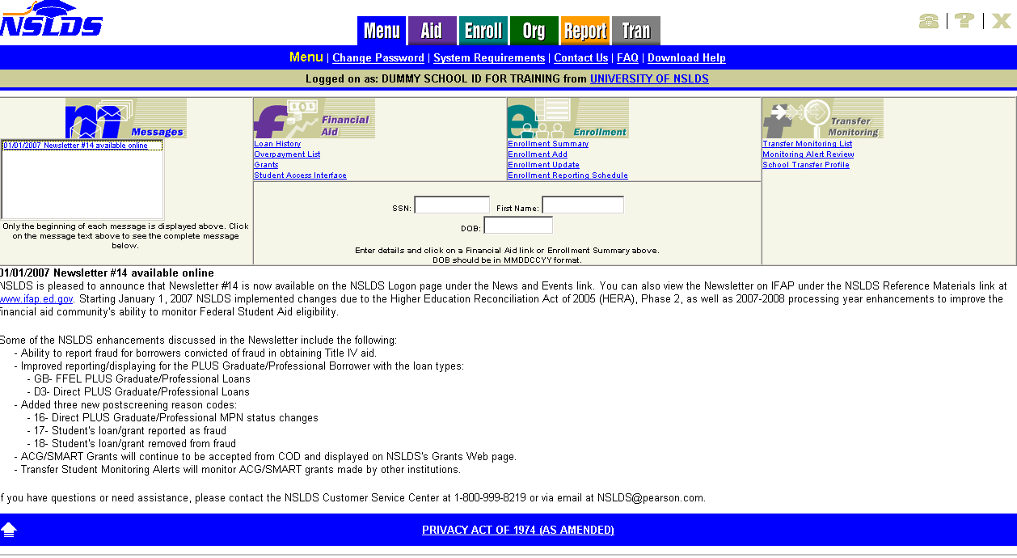
Figure 1–1, NSLDS FAP Menu Page

School Transfer Profile

School Transfer Profile Add
The School Transfer Profile Add page is the first page a school must complete before using the Transfer Student Monitoring process. The School Transfer Profile Add page (Figure 2–1) allows you to create your School Transfer Profile information. You must complete this page before submitting your first Inform data.

Note: Some main or branch campus schools may not accept mid-year transfer students. In these cases—at a minimum—it is recommended that your main campus school code (Branch “00”) establish a School Transfer Profile page.

- If a school attempts to add a student to its Transfer Monitoring List via batch before completing this page, NSLDS will send back an error file.

- If a school user tries to access any of the Transfer Monitoring functions when a School Transfer Profile has not been established, he or she will be directed to the School Transfer Profile Add page.

This page will only display once. After the information on this page is completed, a school must use the School Transfer Profile Update page to make any changes.

The School Transfer Profile Add page displays the following:

- Title of Page—School Transfer Profile Add.

Directly below the title are the following text boxes that the school must complete:

- First Name—The first name of the school contact.

- Last Name—The last name of the school contact.

- Title—The school contact’s title.

- Phone—The school contact’s phone number and extension.

- E-mail—The e-mail address provided by the school for Alert notifications. You may use a group e-mail address established by your school if you would like more than one person to receive messages. If an Alert has been generated for your school, NSLDS sends an Alert e-mail notification to your designated e-mail address instructing you to view your Alert information.

- Inform—The TG mailbox from which Inform files will be submitted. Anyone with a user ID associated with this school can submit an Inform file via batch. A school also can request that an outside agency, such as a servicer, submit Inform files. However, the school must provide a TG# from which those files will be sent.

Note: A TG# is the SAIG mailbox used to transmit data. It starts with “TG.”

- Alert—A school must designate whether it wants Alert information via the Web Only or via Web and Batch Files. One of these boxes must be checked. A TG# must be provided by the school if Web and Batch File is selected.

- SAIG Mailbox—If the school designated Web and Batch Alerts as the output option, provide the TG# to which those Batch Alerts will be sent, which is provided by the school. If the school requested Web Only Alerts, this box is blank.

- Servicer/Non-Servicer Batch Alert Method—This gives schools the option to receive Alert files in either Extract or Report format. The Extract format is strictly a string of data, usually imported into a spreadsheet format, such as Excel™. The Report format presents the data in an easily readable report.

The minimum information required for a School Transfer Profile includes:

- First and Last Names
- Phone number and extension
- E-mail address
- Alert Method
- Servicer/Non-Servicer Batch Alert Method (if chosen by the school)

The School Transfer Profile Add page is completed when you click Submit at the bottom of the page. This takes you back to the School Transfer Profile page with a message that the Add has been performed successfully.

Note: Do not use this page to add students to the school’s Transfer Monitoring List. This is the school profile information only.

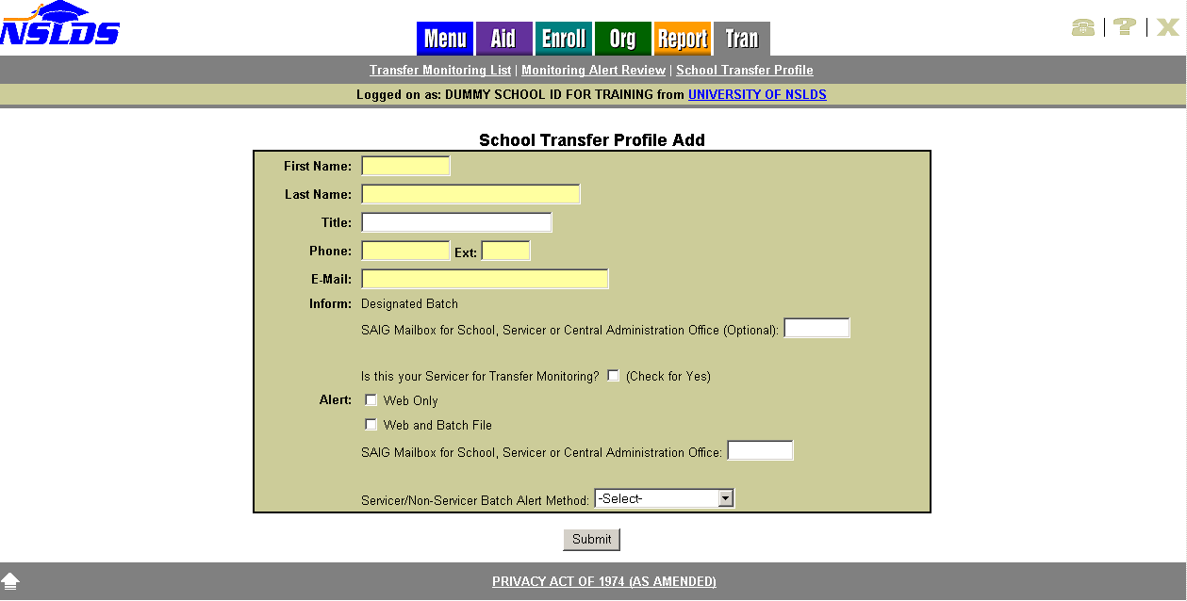
Figure 2–1, School Transfer Profile Add Page

School Transfer Profile
The School Transfer Profile page (Figure 2–2) provides information about the school contact for the Transfer Monitoring process. Several items are displayed once the School Transfer Profile is completed: the contact’s name, title, phone number, and e-mail address, as well as the Inform and Alert options selected by the school. It also shows the name of the last person to update the page and the date of the update.

The School Transfer Profile page displays the following:

- Title of Page—School Transfer Profile.

- Update Button—Directly below the title. This links to the School Transfer Profile Update page.

Directly below the Update button is the information on record for the school for Transfer Monitoring. This information is provided by the school and includes the following:

- First Name—The first name of the school contact.

- Last Name—The last name of the school contact.

- Title—The school contact’s title.

- Phone—The school contact’s phone number and extension.

- E-mail—The e-mail address for Alert notifications. You may use a group e-mail address established by your school if you would like more than one person to receive messages. If an Alert has been generated for your school, NSLDS sends an Alert e-mail notification to your designated e-mail address instructing you to view your Alert information.

- Inform—If the school has not designated anyone outside the school to submit Inform files or chooses to submit Inform files solely through the Web, this box is blank. However, if the school or outside agency submits Inform files via batch, a TG# must display in the Inform box.

- Inform Org—The organization’s name associated with the SAIG mailbox for batch Informs. This may appear blank if the user is not using a batch interface (via the SAIG mailbox).

- Alert—Identifies whether the school requested the Alert information to be viewed on the Web Only or viewed on the Web and Batch Files sent through SAIG.

- SAIG Mailbox—If the school designated Web and Batch Alerts as the output option, this box shows the TG# to which those Batch Alerts will be sent, which is provided by the school. If the school requested Web Only Alerts, this box is blank.

- Alert Org—The organization’s name associated with the SAIG mailbox for Batch Alerts. This may appear blank if the user is not using a batch interface (via the SAIG mailbox).

- Batch Alert Method—If the school designated Web and Batch Alerts as the output option, this box shows whether the Alert is to be provided in an Extract or Report format, as requested by the school.

- Last Update By—This box displays the name of the last person who made an update to the School Transfer Profile and the date of that update.

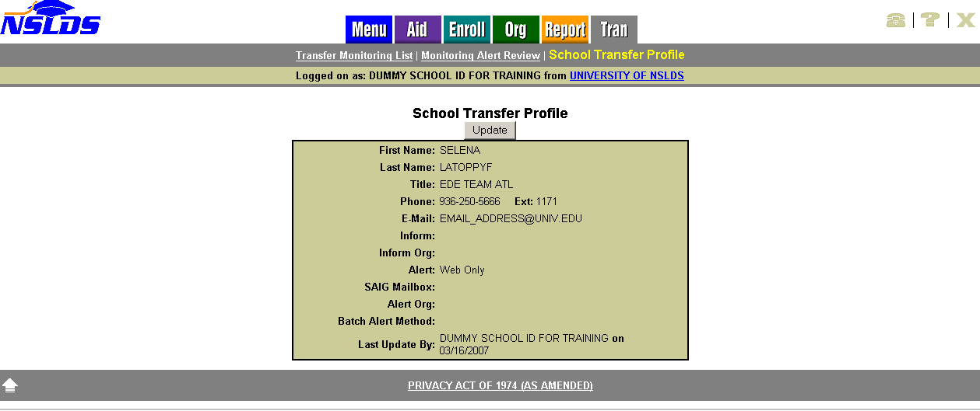
Figure 2–2, School Transfer Profile Page

School Transfer Profile Update
The School Transfer Profile Update page (Figure 2–3) allows you to update the School Transfer Profile information.

The School Transfer Profile Update page displays the following:

- Title of Page—School Transfer Profile Update.

- Left Arrow Icon—Click to return to the School Transfer Profile page.

Directly below the title are the following boxes, which can be updated except for the Last Update By line. These boxes display information that has been previously provided by the school:

- First Name—The first name of the school contact.

- Last Name—The last name of the school contact.

- Title—The school contact’s title.

- Phone—The school contact’s phone number and extension.

- E-mail—The e-mail address for Alert notifications. It can also be set up as a group e-mail address. If an alert has been generated for your school, NSLDS sends an alert e-mail notification to your designated e-mail address instructing you to view your alert information.

- Inform—The TG number source the school identifies when submitting batch Inform files. If the school uses an outside agency, such as a servicer, the TG number should belong to the servicer. You will also need to designate that it is a servicer’s TG# by clicking “Yes” to the question “Is this your Servicer for Transfer Monitoring?” If the school does not plan to use batch Inform files, then leave the Inform SAIG mailbox blank.

- Alert—Identifies whether the school requested the Alert information to be sent via the Web Only or via Web and Batch Files through SAIG.

- SAIG Mailbox—If the school designated Web and Batch Alerts as the output option, this box is for the TG# to which those Batch Alerts will be sent. If the school requested Web Only Alerts, this box is left blank.

- Servicer/Non-Servicer Batch Alert Method—If the school designated Web and Batch Alerts as the output option in this box, select whether the Alert will be provided in an Extract or Report format.

- Last Update By—This box displays the name of the last person to make an update to the school’s Transfer Profile and the date of that update. After your changes are submitted, your name and the new date will appear.

To update the School Transfer Profile, click Submit at the bottom of the page.

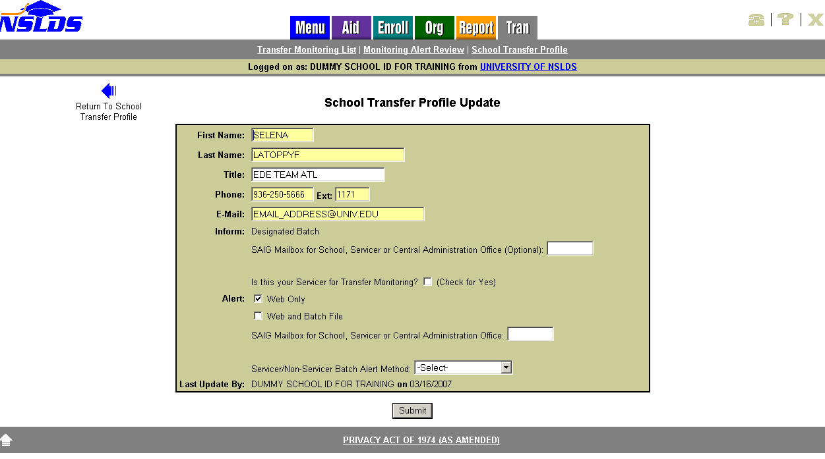
Figure 2–3, School Transfer Profile Update Page

Student Monitoring

Student Monitoring Add
The Student Monitoring Add page (Figure 3–1) allows you to use the Web to inform NSLDS of students to be added to the Transfer Monitoring List. If you are adding a student to the Transfer Monitoring List who is not in the NSLDS database, the student is only added to the Transfer Monitoring List and does not display on any other pages of the NSLDS FAP Web site. This page is accessible from the Transfer Monitoring List page, or from a student’s Loan History page or Grants History page.

The Student Monitoring Add page displays the following:

- Student Search Boxes—The boxes displayed are standard. You can type a student’s Social Security number (SSN), First Name, and date of birth (DOB)—or SSN only—then click Retrieve to retrieve student information from NSLDS.

- Student Identifiers—Directly below the Student Search are the standard identifiers with student’s name, SSN, and DOB. They display after you click Retrieve, or if you access this page from the student’s Loan History or Grants History page.

- Left Arrow Icon—Click to return to the Transfer Monitoring List page.

- Title of Page—Student Monitoring Add.

Directly below the title are the following:

SSN—The student’s Social Security number. This is pre-filled when adding a student from the Loan History, Grants History, or Transfer Monitoring List pages.

- First Name—The student’s first name. It automatically displays when the Student Monitoring Add page is accessed from the Loan History, Grants History, or Transfer Monitoring List pages, assuming a student has been selected.

- Last Name—The student’s last name. It automatically displays when the Student Monitoring Add page is accessed from the Loan History, Grants History, or Transfer Monitoring List pages, assuming a student has been selected.

- Date of Birth—The student’s date of birth. It automatically displays when the Student Monitoring Add page is accessed from the Loan History, Grants History, or Transfer Monitoring List pages, assuming a student has been selected.

- Enrollment Begin Date—The date reported for when a student is to begin classes at the school. You must type a date in this box. There is a standard date prompt to the right of the box.
- Monitor Begin Date—The date NSLDS is to begin monitoring the student. Today’s date will display. This date can be changed as necessary. You can request that monitoring begin on a future date. Make sure that the future date is not after the date you have listed as the Enrollment Begin Date. There is a standard date prompt to the right of the box.

To add the student to the school’s Transfer Monitoring List, click Submit.

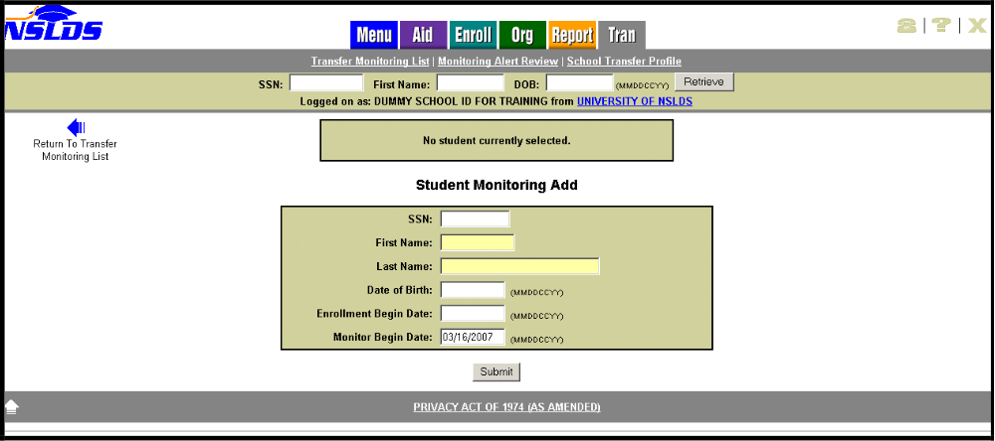
Figure 3–1, Student Monitoring Add Page

Loan History
The Loan History page allows you to link to the Student Monitoring Add page or the Student Monitoring Detail page, depending on whether the student is on the Transfer Monitoring List for your school. Below the student identifiers, the information symbol and a button appear.

- If the student displayed is not on the Transfer Monitoring List for your school, the Add Student to Monitoring List button appears (Figure 3–2). Clicking this links you to the Student Monitoring Add page (Figure 3–1). You will only need to complete the Enrollment Begin Date and submit to have the student added to your Inform list.

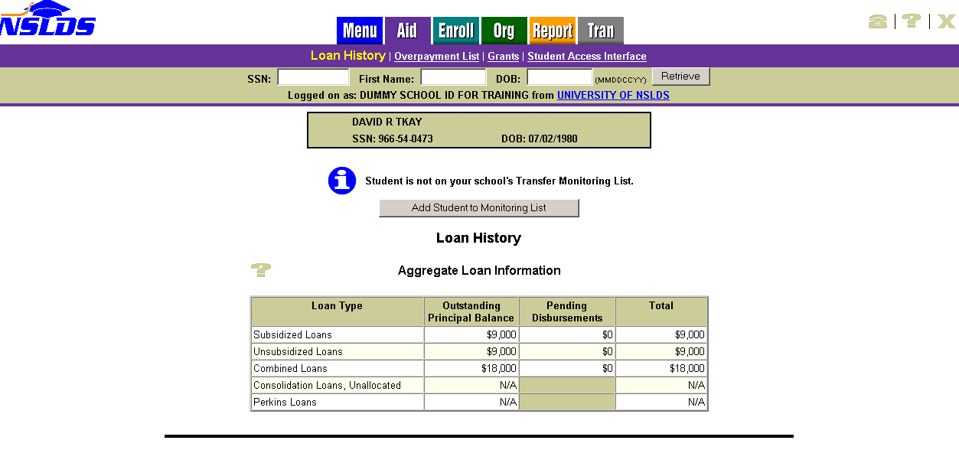
Figure 3–2, Loan History Page—Add Student to Monitoring List Button

- If the student displayed is already on the Transfer Monitoring List for your school, the Student Monitoring Detail button appears on the Loan History page (Figure 3–3). Clicking this links you to the Student Monitoring Detail page (Figure 3–7).

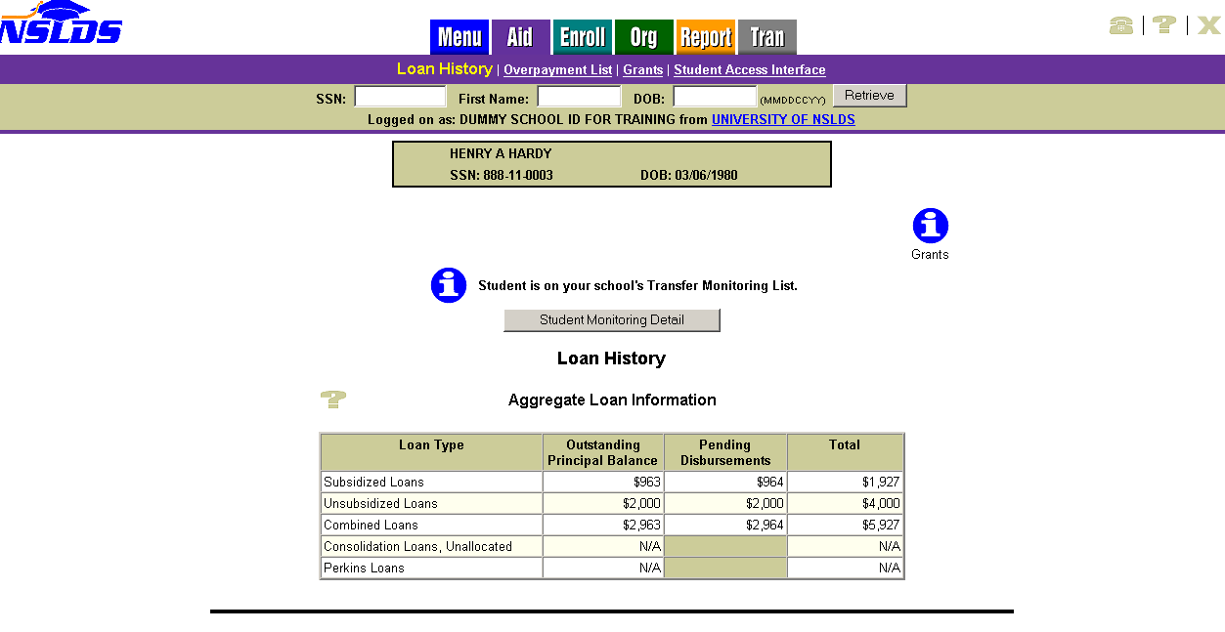
Figure 3–3, Loan History Page—Student Monitoring Detail Button

Grants
The Grants History page allows you to link to the Student Monitoring Add page or the Student Monitoring Detail page, depending on whether the student is on the Transfer Monitoring List for your school. Below the student identifiers, an information symbol and a button appear.

- If the student displayed is not on the Transfer Monitoring List for your school, the Add Student to Monitoring List button appears on the Grants History page (Figure 3–4). Clicking this link directs you to the Student Monitoring Add page (Figure 3–1). You will only need to complete the Enrollment Begin Date and submit to have the student added to your Inform list.

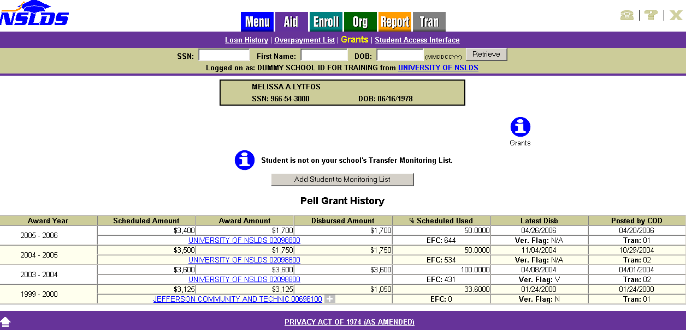
Figure 3–4, Grant History Page—Add Student to Monitoring List Button

- If the student displayed is already on the Transfer Monitoring List for your school, the Student Monitoring Detail button appears on the Grants History page (Figure 3–5). Clicking this links directs you to the Student Monitoring Detail page (Figure 3–7).

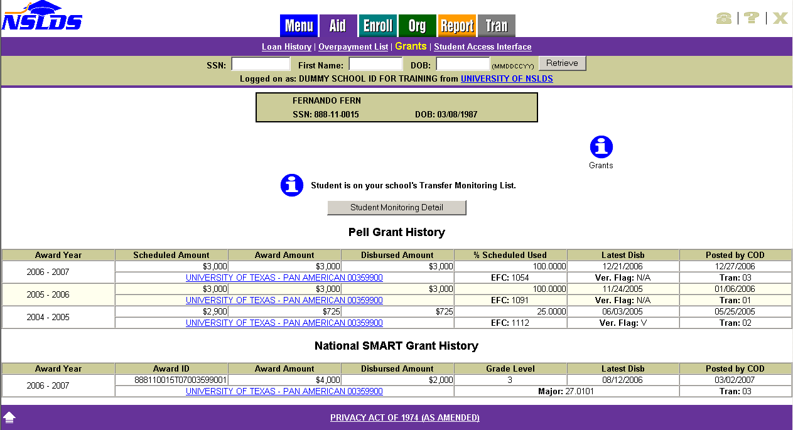
Figure 3–5, Grant History Page—Student Monitoring Detail Button

Transfer Monitoring List
The Transfer Monitoring List page (Figure 3–6) lists all students that were submitted by the school via the online Student Monitoring Add page or via the Transfer Monitoring Inform batch file. If it was submitted online, the name associated with the user ID displays. If it was submitted via an Inform batch file, it displays “BATCH.”

The Transfer Monitoring List page is the default page displayed when you click the Tran tab after your initial completion of the School Transfer Profile Add page.

The Transfer Monitoring List page displays the following:

- Title of Page—Transfer Monitoring List.

- Add Student to Monitoring List Button—Directly below the title. When you click Add Student to Monitoring List, you link to the Student Monitoring Add page.

- Sort By—Directly below the Add Student button. The default sort order for this list is alphabetical by Student Last Name. You are able to sort by the following items using the dropdown arrow:

- Name
- SSN
- Enrollment Begin Date
- Monitor Begin Date
- Last Changed By

- Display Only—You can filter the list by using the Display Only box. You are also able to specify a group of students on the list to be displayed by the following:

- SSN
- Last Name
- Enrollment Begin Date
- Monitor Begin Date
- Last Changed By

Sorting/filtering occurs when you click Retrieve. You are able to view the list without having to make any changes. The list displays up to 125 students per scrollable page. Next and Previous arrows are displayed at the bottom and top of page, respectively.

Each student is displayed in the following order, reading from left to right across the page:

- Active Bullet Number Icon—Numbering does change with sorting. Clicking the hyper-linked blue numbered bullet takes you to the Transfer Monitoring Detail page.

- SSN—The student’s Social Security number. If the student has had an Alert sent from NSLDS, there will be an Alert icon displayed next to the Social Security number.

- Name—The student’s first and last name as reported by the school on the Inform file.

- DOB—The student’s date of birth. If the student was added to the Transfer Monitoring List, but is not in NSLDS, the DOB provided by you is displayed.

- Enrollment Begin Date—The date that the student began classes at the school.

- Monitor Begin Date—The date NSLDS began or is to begin monitoring the student.

- Last Changed By—This box displays the name of the person who made the last update to this student’s monitoring record, and the date that change was made. If there have been no updates since the student was added to the list, the name of the user who added the student is displayed along with the date that the student was added. If the student was added or last updated via batch process, “BATCH” and the process date display.

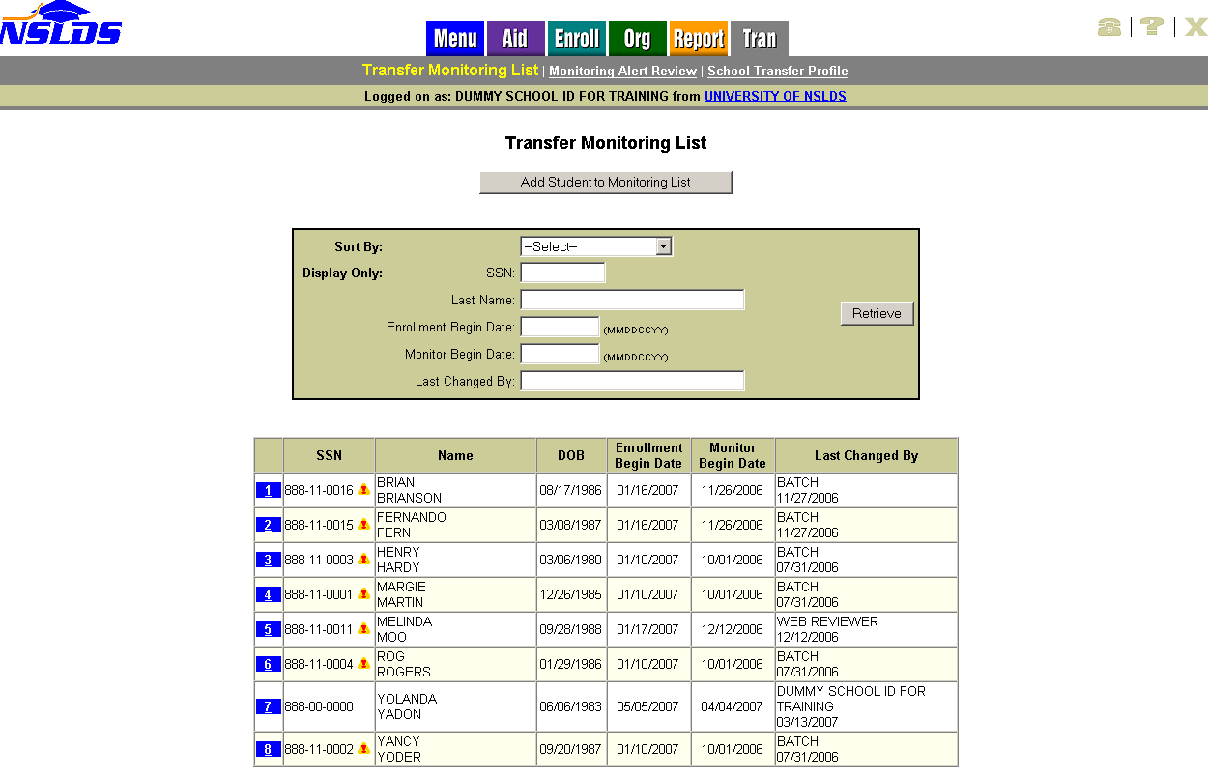
Figure 3–6, Transfer Monitoring List Page

Student Monitoring Detail
The Student Monitoring Detail page (Figure 3–7) provides detailed transfer monitoring student information that can be updated or deleted. It is accessible from the Loan History page, Grants History page, or Transfer Monitoring List page. To access this page from the Transfer Monitoring List, click the hyperlinked blue numbered bullet icon next to the student’s information.

The Student Monitoring Detail page displays the following:

- Title of Page—Student Monitoring Detail.

- Left Arrow Icon—Click to return to the Transfer Monitoring List page.

- Update Button—Located directly below the title. To update the student’s record, click the Update button. This links you to the Student Monitoring Update page.

- Delete Button—Located directly beside the Update button. To delete the student’s record from the Monitoring and Alert lists, click the Delete button. This links you to the Student Monitoring Delete page.

- Student Information—Following the Update and Delete buttons. This information is from the school’s Inform file:

- SSN—The student’s Social Security number.

- First Name—The student’s first name.

- Last Name—The student’s last name.

- Date of Birth—The student’s date of birth.

- Enrollment Begin Date—The date that the student is to begin classes at the school.

- Monitor Begin Date—The date NSLDS is to begin monitoring the student.

- Last Changed By—This box displays the name of the person who made the last update to this student’s monitoring record, and the date that change was made. If there have been no updates since the student was added to the list, the name of the user who added the student is displayed along with the date that the student was added. If the student was added or last updated via batch process, “BATCH” and the process date display.

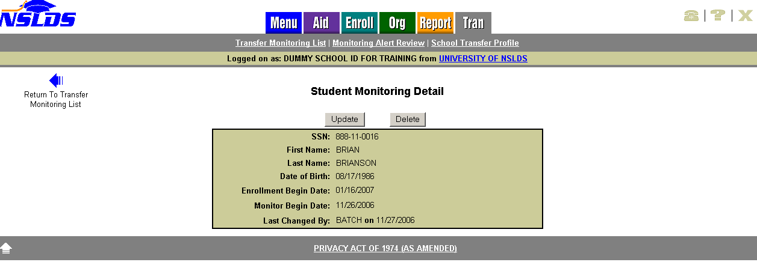
Figure 3–7, Student Monitoring Detail Page

Student Monitoring Update
The Student Monitoring Update page (Figure 3–8) allows you to update the student’s Transfer Monitoring Detail information and is accessible from the Student Monitoring Detail page.

The Student Monitoring Update page displays the following:

- Title of Page—Student Monitoring Update.

- Left Arrow Icon—Click to return to the Student Monitoring Detail page.

Directly below the title is a student specific box with the student’s SSN and the following text boxes, all of which may be updated:

- First Name—The student’s first name.

- Last Name—The student’s last name.

- Date of Birth—The student’s date of birth.

- Enrollment Begin Date—The date that the student is to begin classes at the school.

- Monitor Begin Date—The date NSLDS is to begin monitoring the student. You can request that monitoring begin on a future date. Make sure that the future date is not after the date you have listed as the Enrollment Begin Date.

To update the information, click Submit.

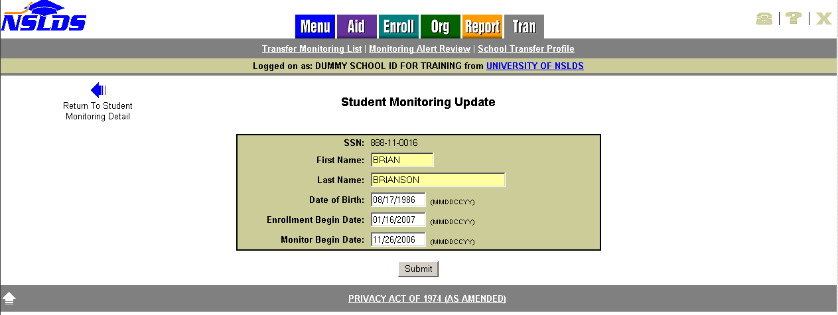
Figure 3–8, Student Monitoring Update Page

Student Monitoring Delete
The Student Monitoring Delete page (Figure 3–9) allows you to delete the student from your school’s Transfer Monitoring List. Student Monitoring records should only be deleted if the student will not be attending your school or was added in error. Do not delete a student simply to stop monitoring him or her.

The Student Monitoring Delete page appears after you click Delete on the Student Monitoring Detail page. This page confirms the student’s deletion from the Transfer Monitoring process. Once the delete has been confirmed, the student’s information is removed from the Monitoring list and Alert list, if applicable.

The Student Monitoring Delete page displays the following:

- Title of Page—Student Monitoring Delete.

- Left Arrow Icon—Click to return to the Student Monitoring Detail page.

- Delete Confirmation Statement—Displays beneath the title. This statement confirms that you wish to delete student monitoring information.

Directly below the Delete Confirmation Statement, the following student information is displayed:

- SSN
- First Name
- Last Name
- Date of Birth
- Enrollment Begin Date
- Monitor Begin Date
- Last Changed By and Date of the Change

To delete a record, click Confirm at the bottom of the page. Once the deletion has been confirmed, the student’s information will be removed from the Monitoring and Alert list(s). Deletion does not remove the student from the Monitoring table; it just ends the Monitoring and removes the student from viewable lists online. A record of the deletion is maintained by NSLDS for auditing purposes.

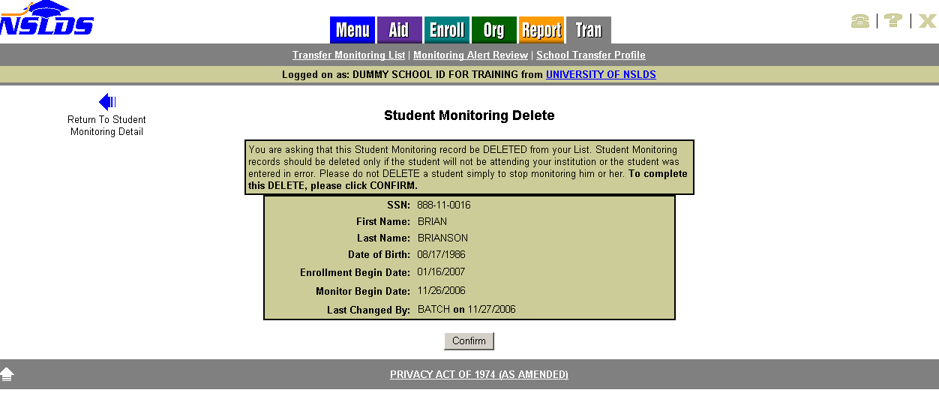
Figure 3–9, Student Monitoring Delete Page

Monitoring Alert

Monitoring Alert Review
The Monitoring Alert Review page (Figure 4–1) lists all students on a school’s Transfer Monitoring List for whom relevant changes have been reported.

NSLDS sends a school an Alert on any student listed on that school’s Transfer Monitoring List whenever a relevant change has been reported on that student’s record. Any authorized NSLDS user for a school can view that school’s current Monitoring Alert Review list online at any time. In addition, a school can request that any Alerts be sent in a batch file via its SAIG mailbox. The school’s request Alert method is displayed on the School Transfer Profile in the Alert and Alert Org boxes (Figure 2–2).

Note: Go to the School Transfer Profile Update page (Section 2.3) if you would like to change the method in which NSLDS sends your school an Alert.

A student’s record will be monitored for up to 90 days after the Enrollment Begin Date reported by the school. On the 91st day, the records will drop off both the Transfer Monitoring List and Monitoring Alert Review pages.

The Monitoring Alert Review page displays the following:

- Title of Page—Monitoring Alert Review.

- Monitoring Results as of—Located directly below the title. This date line is automatically updated after NSLDS runs the weekly Monitoring process. This line allows you to see quickly when the last Monitoring process occurred.

- Sort By/Display Only—Located directly below the message. The default sort order for this list is alphabetical by Student Last Name. The default display sort order for the Transfer Monitoring List is broken into two sections: Reviewed and Not Reviewed. A record with no check mark in the Reviewed box will display at the top of the list alphabetically by last name. Records that have check marks in the Reviewed boxes will display next, also alphabetically by last name. You are able to sort by:

- Name
- SSN
- Alert Date
- Enrollment Begin Date
- Monitor Begin Date
- Loan First
- Grant First

- Display Only—You can filter the list by using these boxes. Filtering allows you to specify a group of students on the list to be displayed by the following student information:

- SSN
- Last Name
- Date Alerted
- Enrollment Begin Date
- Loans Only
- Grants Only

Sorting/filtering will take place when you click Retrieve.

You are able to view the list without having to mark any changes Reviewed. The list displays up to 75 changes per scrollable page, then adds Next and Previous arrows to bottom and top of page, respectively.

Each student is displayed in the following order, reading from left to right across the page:

- SSN—The student’s Social Security number.

- Name—The student’s first and last name.

- DOB—The student’s date of birth.

- Change/Reviewed—This box lists links to the changes that prompted the Alert. A column of check boxes is also displayed. Once the change is reviewed, check the box immediately to the left of the change. Checking the box determines the placement of the student’s Alert record on the list. Clicking the link to the changed information does not check the box automatically. If the school requested that its Alerts be sent via batch file, any change reported via batch is automatically checked online as Reviewed.

- Date Alerted—The date when NSLDS added the student’s name/change to the Monitoring Alert Review list and/or sent a batch Alert on the student to the school, if that is the chosen output method.

- Enrollment Begin Date—The date that the student began classes at the school.

- Monitor Begin Date—The date when NSLDS began monitoring the student.

The Submit button at the bottom of the page re-orders the list by checked Reviewed boxes.
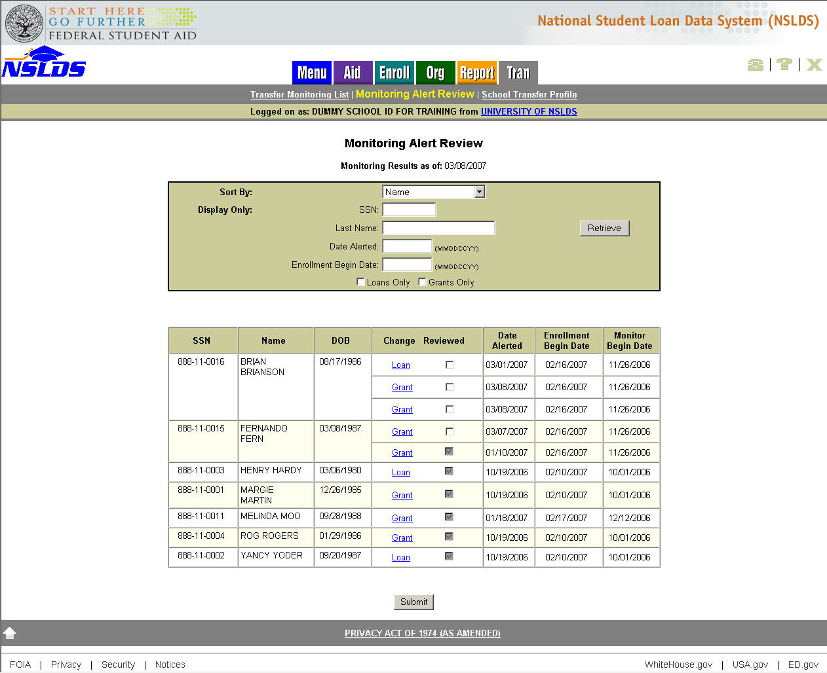
Figure 4–1, Monitoring Alert Review Page

Loan Alert Display
The Loan Alert Display page (Figure 4–2) is accessible from the Monitoring Alert Review page and allows users to review the most recent information reported that may affect a student’s eligibility for Title IV loans at his or her school.

Changes that prompt an Alert for loans are:

- New loan reported [Federal Family Education Loan (FFEL), Direct Loan, or Perkins].

- New disbursement or reduction in disbursed amount on an existing loan (FFEL, Direct Loan, or Perkins).

- A change in the amount of Outstanding Principal Balance (OPB) on an existing loan (FFEL, Direct Loan, or Perkins).

Note: The OPB History page displays the changes made to the amounts.

- New, increased, or decreased cancellation amount reported on a loan.

- Change in amount of loan (FFEL, Direct Loan, or Perkins).

If the student had a relevant change reported on a loan, the Loan link appears on the Monitoring Alert Review page. Clicking Loan links you to the student’s Loan Alert Display page (Figure 4–2) for that specific loan to view the change reported.

If the student has changes to more than one loan, there are multiple links, each going to a different Loan Detail page.

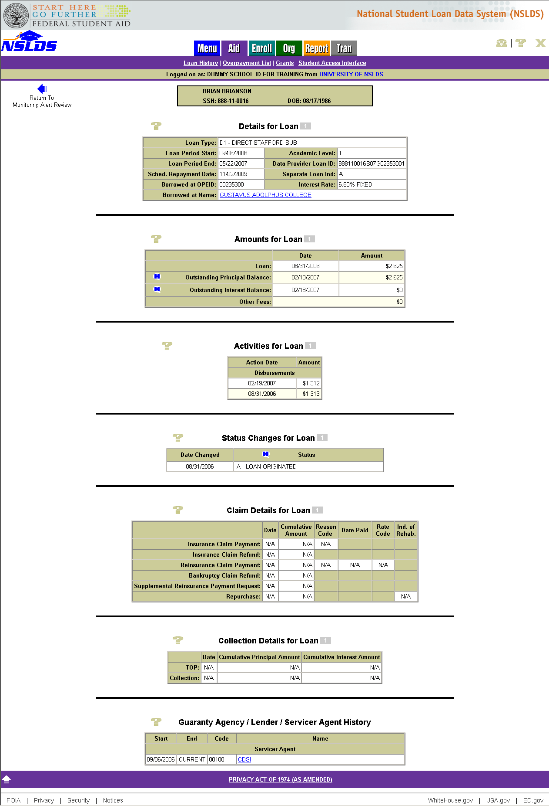
Figure 4–2, Loan Alert Display Page

Grant Alert Display
The Grant Alert Display page can be accessed from the Monitoring Alert Review page and shows reported changes that may affect a student’s eligibility for Pell, Academic Competitiveness Grants (ACGs), or National Science and Mathematics Access to Retain Talent (SMART) Grants.

Changes that prompt an Alert for Grants are:

- New Pell, ACGs, or National SMART Grants reported.

- New disbursements or reduction in disbursed amount on existing Pell, ACGs, or National SMART Grants.

- Change in Award Amounts for Pell, ACGs, and National SMART Grants.

- Changes in Pell Grant percentages.

If the student had a relevant change reported on a Grant, the Grant link will appear on the Monitoring Alert Review page. Clicking Grant links you to the student’s Grant Alert Display page (Figure 4–3) to view change(s) reported for Pell, ACGs, and National SMART Grants.

If a student has changes to more than one Grant/Grant type on the same alert day, you will see multiple Grant links available for review.

Note: A blue ® icon will display to the left of the grant that is under review only when the student’s Grant History is accessed from the Monitoring Alert Review page. The ® will not be visible if the student’s Grant History is accessed from the Menu or Aid tabs.

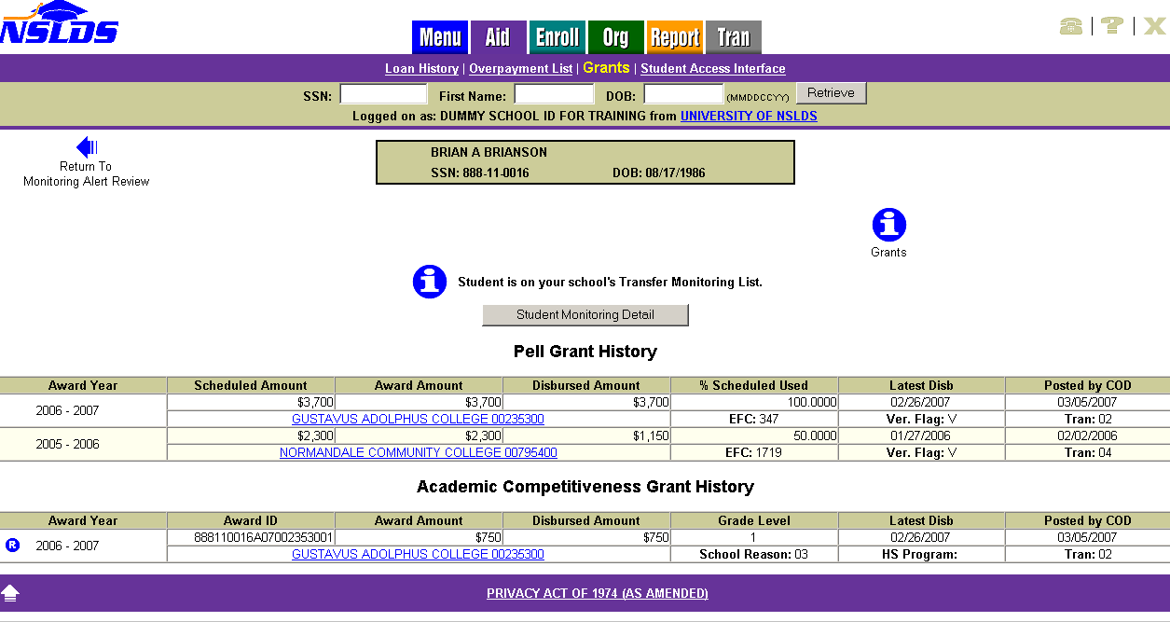
Figure 4–3, Grant Alert Display Page

Additional Information

Transfer Monitoring Summary Report
The Transfer Monitoring Summary Report can be requested on the NSLDS Web site from the Report tab by selecting Report ID SCH07B. This report provides school users with a list of students (by SSN) who were part of the school’s Transfer Monitoring process within a given timeframe. The processed report is available in either Extract (file layout) or Report format.

The Transfer Monitoring Summary Report has various functions. These include to:

- Assist Financial Aid Administrators (FAAs) with the Transfer Student Monitoring process.

- Verify if schools are actively using the Transfer Student Monitoring process.

- Verify whether Alerts are being generated for oversight and auditing purposes.

- Aid in reconciliation when a student’s Transfer Student Monitoring record falls off the Transfer Monitoring List and Monitoring Alert Review pages. This occurs on the 91st day after the Enrollment Begin Date.

You can generate the Transfer Monitoring Summary Report for your school by filling in the Report Parameters (Figure 5–1):

- Type—Select whether you want to receive either Extract (file layout) or Report format.

- Range Type—You can search in two ways:

1. Enrollment Period Begin Date—The date that the student began enrollment at the school.
2. Monitor Begin Date—The date NSLDS began monitoring the student.

- Beginning Date Range—The earliest start date of the range you want to use to search the school’s Transfer Student Monitoring lists.

- Ending Date Range—The end date of the range you want to use to search the school’s Transfer Student Monitoring lists.

- Sort By—The report will be sorted by SSN.

- Output Medium: SAIG—The report will be delivered to the SAIG TG Mailbox associated with your NSLDS online user ID within 24–48 hours.

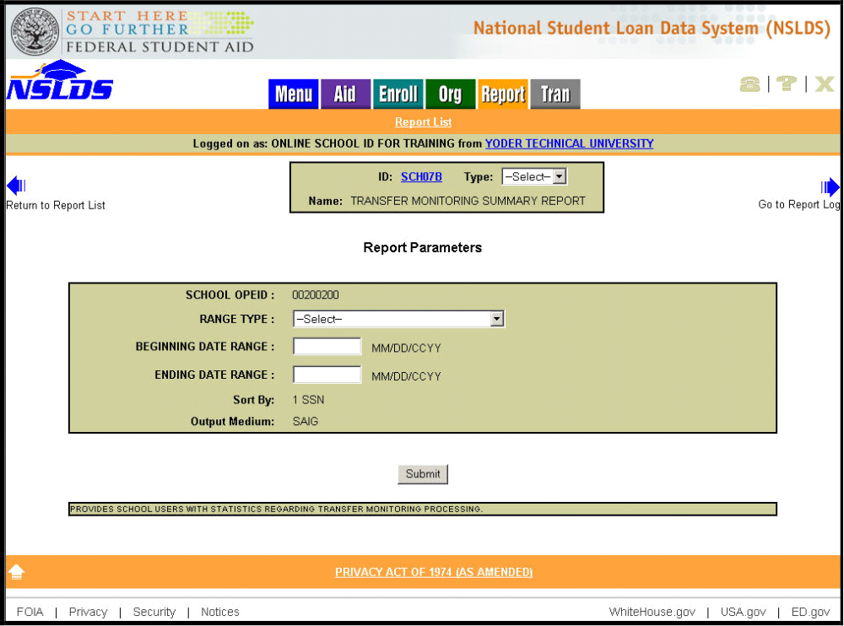
Figure 5–1, Transfer Monitoring Summary Report Parameters

Figure 5–2 shows a sample of the processed report that will be generated if you select “Report” as your output type.

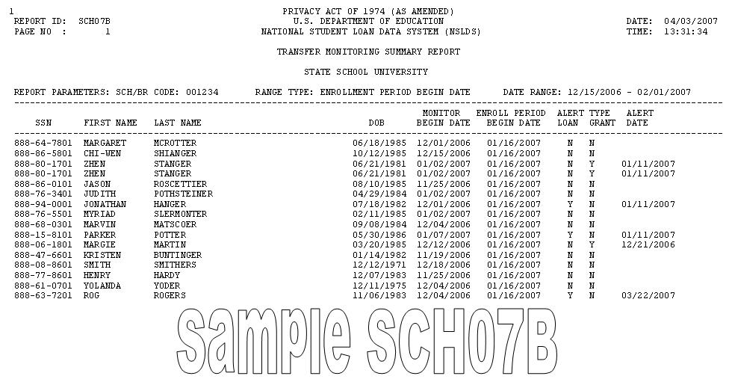
Figure 5–2, Transfer Monitoring Summary Report

Organization Contact
The Organization Contact List page (Figure 5–3) can be accessed on the NSLDS Web site from the Org tab. It enables each school to designate a contact specifically for Transfer Monitoring questions. This contact does not have to be the same as the one listed on the School Transfer Profile. This contact information can be viewed by other schools, Guaranty Agencies, servicers, and other users of NSLDS.

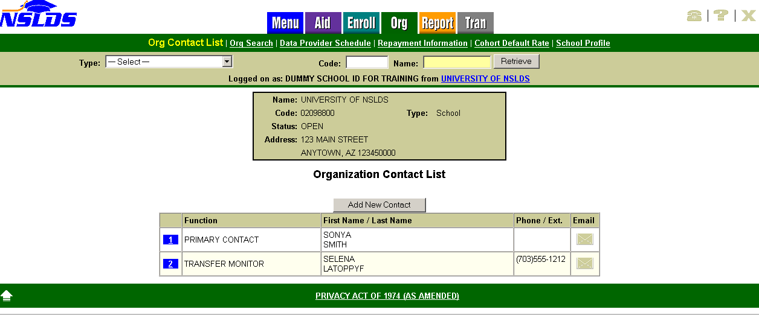
Figure 5–3, Organization Contact List Page

