September 25, 2002

Experimental Sites Partners:

We are pleased to present the automated template of the reporting formats for the Experimental Sites Initiative. The reporting formats are required for the 2001-2002 reporting cycle.

The templates are contained in one Microsoft Office Excel spreadsheet. The spreadsheet was created in Microsoft Excel 97. The spreadsheet contains: 1) a Demographical Background worksheet, and 2) nine worksheets, one for each experiment. There is a separate spreadsheet for the Ability to Benefit experiment.

How to Navigate through the worksheets:

- Place your cursor and click on the template you wish to open, e.g. Demographic worksheet, to go to the Demographic Worksheet.
- Use the ‘black arrows’ at the lower left of the worksheet to advance the status bar to other worksheet pages.

What is the Demographic Background?

The very first worksheet is the Demographic Worksheet. It is used to give very basic information about your institution: name, OPE ID, Total number of Title IV recipients for 2001-2002, etc., and pertinent information about your Experimental Sites Coordinator.

The Total 2001-2002 number of Title IV recipients and FFEL/Direct Loan volume is needed as a reference background for some of the reporting items.

What information is contained on the worksheet for each experiment?

The worksheet for each experiment contains standard information at the top of the worksheet: institution name, the name of the experiment, the reporting year, the goal of the experiment and the target student population for the experiment.

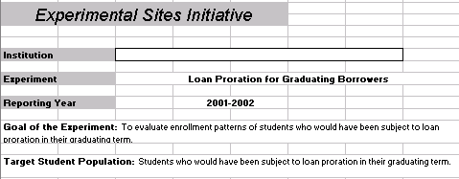

- Your institution’s name is the only information you need to enter at the top of the page. Please your cursor in the box and type.

- The next area on the worksheet for each experiment is the Reporting Items area. The first reporting item in each worksheet asks for a description of how the institution conducted the experiment. This information should be entered on a “Description” worksheet, which will be discussed later.

- The “Supplemental Items” are optional. However, we strongly encourage you to provide data for the Supplemental Items because it is an invaluable support for change.

- The last area on the experiment worksheet is for your “Conclusions about this experiment”. This area is provided for any summary comments you may have about the experiment. To enter data: Click in the box to select it. At the top of the screen you will see the data entry box.

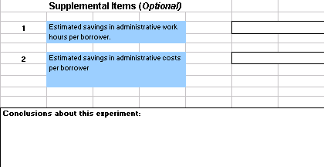

In the data entry box, place your cursor at the end of the text, Conclusions about this experiment, and begin typing your concluding remarks.
What are the Description Worksheets?

- The first reporting item in each worksheet asks for a description of how the institution conducted the experiment. You should complete a description worksheet for each experiment in which you participate. There are 9 description worksheets included on the status bar. The instructions for entering data are the same as the instruction for entering data for “Conclusion…”. To enter data on a description worksheet: 1) Go to the status bar at the bottom of the worksheet. 2) Use the “arrows” to move to a description worksheet. 3) Click on a description worksheet to select/highlight it. 4) Click in the large text box on the worksheet where information is to be entered. 5) At the top of the screen you will see the data entry box. 6) In the data entry box, place your cursor at the end of the text, Provide brief description …, and begin typing the information.

What should I do if I cannot open the Excel document?

Contact Jackie Bannister at (202) 377-4376 or email her at Jackie.Bannister@ed.gov

What is the deadline date to forward the completed template?

The annual reporting deadline date for reports on 2001-2002 activity is November 1, 2002. Please transmit the completed Excel file to the Department at the following mailbox: ExperimentalSites@ed.gov

If you have any questions about the recommended reporting items or the template, please contact Jackie Bannister, directly, by telephone or email.

Standardized Reporting has resulted in a most productive outcome for the Experimental Sites Initiative. We are confident these excellent outcomes from standardized reporting will continue in the future.

Thanks

