Department of Education Posted Media on “Debt Relief”

Acting Secretary John King Video:
Don’t be fooled

Secretary Arne Duncan Video:
Don’t Pay for Student Loan Debt Relief
The U.S. Department of Education provides FREE assistance to help you:
- Lower or cap your monthly loan payment;
- Consolidate your federal loans;
- See if you qualify for loan forgiveness;
- Get advice on getting out of default.

Blogs:
Beware of Student Loan Debt Relief Offers and Credit Repair “Deals”
- Student loan debt relief companies charge fees for services that you can get for free.
- Keep your FSA ID to yourself.
- Is Your Loan in Default?
- Think you’ve been scammed?
  - If you’ve already signed a contract, seek advice to learn your options. Many state governments have an Office of Consumer Affairs or Consumer Protection either within or affiliated with, the Office of the State’s Attorney General. At the federal level, the Federal Trade Commission (FTC) and the Consumer Financial Protection Bureau (CFPB) have the authority to act against companies that engage in deceptive or unfair practices. Click on the links to file your complaint with either of those agencies.
- Contact your Loan Servicer.

Beware! You Don’t Have to Pay for Help with Your Student Loans
- Lower Your Monthly Payment
- Consolidate Your Loans
- See If You Qualify For Loan Forgiveness
- Get Out of Default
- Protecting Your Log-In and Account Information
- Do You Think You’ve Been Scammed or Need a Resolution?

Social Media:
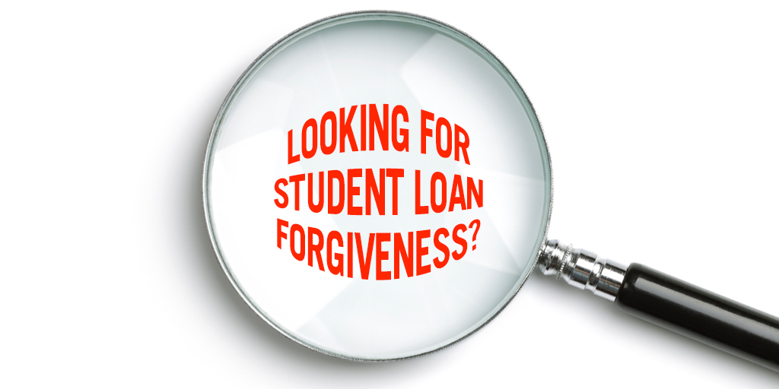
Facebook:
- If you need help managing your student loans, the U.S. Department of Education's loan servicers can help you for FREE: http://1.usa.gov/1Rx5ES0
- You don't have to pay someone to help you with your student loans. The U.S. Department of Education's loan servicers can help you for FREE. Find out how: http://1.usa.gov/1Rx5ES0
- CAUTION: Watch out for ads offering to help you with your student loans! Some companies charge as much as $999 at start-up or $39/month for services that the U.S. Department of Education and our loan servicers offer for FREE! Contact your loan servicer for FREE help: http://1.usa.gov/1Rx5ES0
- BEWARE of online ads promising student loan forgiveness. These are the official student loan forgiveness programs offered by The U.S. Department of Education: http://1.usa.gov/1S3deWK
You can apply for FREE if you qualify!
- If you've been tempted to click on an "Obama Loan Forgiveness" ad, you need to read this: http://1.usa.gov/1PEThbj
- You NEVER have to pay to consolidate your federal student loans. It is a FREE service provided by the U.S. Department of Education. How to consolidate: http://1.usa.gov/1VdSw6r
- BEWARE of Student Loan Debt Relief "Deals”: Behind on student loan payments or have student loan debt? Watch out for ads that offer help with your student loans. Many companies charge fees! The U.S. Department of Education can help for FREE.

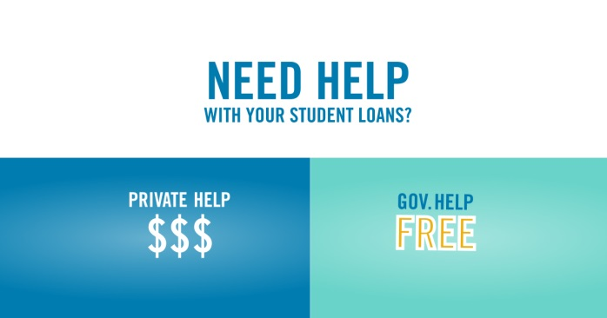

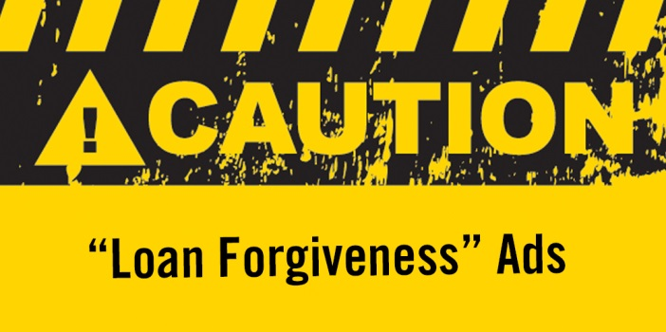

Twitter:
- @FAFSA's loan servicers can help you manage your #StudentLoans for FREE. How to get help: http://1.usa.gov/1Rx5ES0
- Don’t pay for #StudentLoan help. Find out how @FAFSA's loan servicers can help you for FREE: http://1.usa.gov/1Rx5ES0
- CAUTION: Many companies charge fees to help you manage your student loans. Our help is FREE: http://1.usa.gov/1SLWu6h
- BEWARE of #StudentLoan forgiveness ads. @FAFSA loan forgiveness is FREE to apply for: http://1.usa.gov/1S3deWK
- If you've been tempted to click on an "Obama Loan Forgiveness" ad, you need to read this: http://1.usa.gov/1PEThbj
- You NEVER have to pay to consolidate your federal #StudentLoans. Get FREE help from @FAFSA: http://1.usa.gov/1VdSw6r
- "Debt relief" services charge big $ to help with your #StudentLoans. @FAFSA can help for FREE: http://1.usa.gov/1VdSw6r

