  - Financial Aid Shopping Sheet
Implementation Overview
The Financial Aid Shopping Sheet (Shopping Sheet) is a consumer tool that institutions can use to notify students about their financial aid package. This document provides an overview of the various elements required to produce and populate the applicable fields in the Shopping Sheet. Please direct any questions or comments to the U.S. Department of Education (ED) at shoppingsheet@ed.gov.
Shopping Sheet Implementation
The framework/structure of the Shopping Sheet is designed using Hypertext Markup Language (HTML). The HTML code was provided by the U.S. Department of Education on September 28, 2012 through an Electronic Announcement (http://ifap.ed.gov/eannouncements/092812ImplementoftheFinancialAidShopSheet.html).
The Shopping Sheet (Figure 1) consists of three sections: Student Information, Institution Contact Information, and Institutional Metrics.
Student Information
This section of the Shopping Sheet contains information specific to the prospective student, including the estimated cost of attendance, grant and scholarship aid, work options, loan options, etc. More detail on each of the student information elements is provided in the Annotated Shopping Sheet available from the Financial Aid Shopping Sheet webpage (http://www2.ed.gov/policy/highered/guid/aid-offer/index.html).
The data required to populate the Student Information section is provided by the institution.
Institution Contact Information
This area of the Shopping Sheet provides the contact information of the institution.
The data required to populate the Institution Contact Information is provided by the institution.
Figure 1: Financial Aid Shopping Sheet Sections
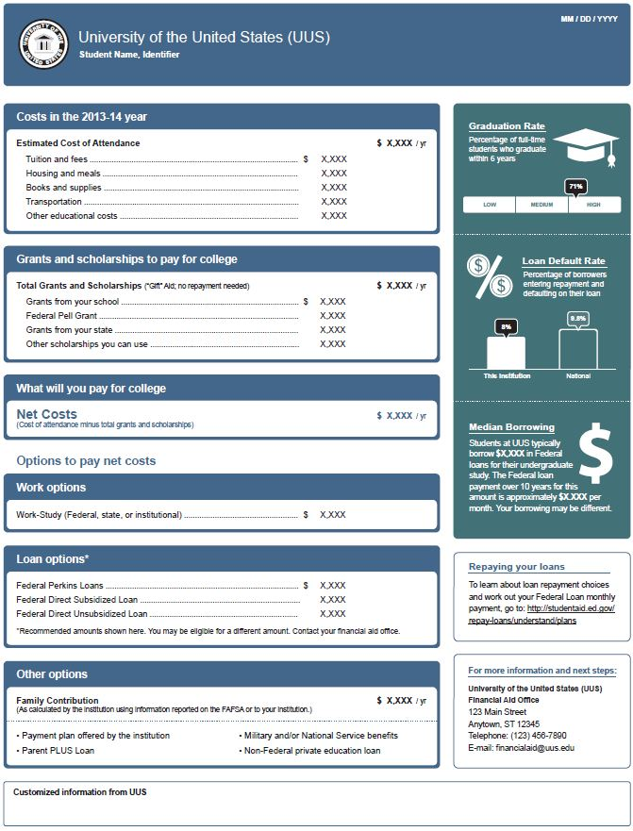
Student Information
(Provided by the institution)
Institutional Metrics
(Provided in the SS_InstitutionalMetricsData.xls file)
Institution Contact Information
(Provided by the institution)

Institutional Metrics
This section contains institutional metrics including comparative information about graduation and loan default rates as well as the median amount of Federal loans borrowed by students at the institution and the corresponding estimated monthly payment over a ten year period.
The data required to produce the Institutional Metrics section is provided by the ED in a Microsoft Excel® file (SS_InstitutionalMetricsData.xls). An institution’s metrics can be found in the file by searching on the 8-digit OPEID. A corresponding schema (SS_Schema.xls) is also provided that outlines the field names and data types in the file.
For the purposes of displaying the graduation rate metric, several data fields are included in the file: Graduation_Rate; GR_Group_Low; GR_Group_LowToMedium; GR_Group_MediumToHigh; GR_Group_High; and Institution_Group. These fields provide the institution’s graduation rate and the cut points for determining whether the rate is low, medium, or high compared to other similar institutions. The schema provides the explanatory text to be displayed with the rate based on the “institution group” to which the institution belongs. If graduation rate data is not available for the institution, the appropriate text to display is included in the schema and an image has been provided (nodata_gr.gif).
For displaying the loan default rate information, the following data fields are included in the file: School_CDR and National_Average_CDR. If the School_CDR field is blank for the institution, the appropriate text to display is included in the schema and an image has been provided (nodata_cdr.gif).
For the median borrowing information the Median_Total_Borrowing field and the Median_Monthly_Payment field are included. If the Median_Total_Borrowing field is blank for the institution, the appropriate text to display in provided in the schema.
Institutional Metric Data Sources
Graduation Rate
The graduation rate is for first-time, full-time degree or certificate-seeking undergraduate students who began at the institution. For primarily bachelor’s degree-granting institutions, the graduation rate displayed is for students beginning in Fall 2005 and seeking a bachelor’s degree. For primarily associate’s degree-granting institutions and primarily certificate-granting institutions, the graduation rate displayed is for students beginning in Fall 2008.
Data used to calculate an institution’s graduation rate come from the institution’s annual submission to the U.S. Department of Education’s Integrated Postsecondary Education Data System (IPEDS).
The institution’s graduation rate is displayed with an indication of how it compares with graduation rates among institutions that primarily grant the same level of award. For example, the comparison group for an institution that primarily awards bachelor’s degrees is all institutions that primarily award bachelor’s degrees. Data from the IPEDS Completions component is used to determine each institution’s group.
Loan Default Rate
Loan default rate refers to the institution’s three-year cohort default rate. This is the percentage of an institution’s borrowers who entered repayment on certain Federal Family Education Loan (FFEL) Program or William D. Ford Federal Direct Loan (Direct Loan) Program loans in Federal fiscal year 2009 (between October 1, 2008 and September 30, 2009) and who defaulted before September 30, 2011.
Data used to calculate an institution’s cohort default rate come from ED’s National Student Data System (NSLDS).

Median Borrowing
Median borrowing refers to the median amount of Federal student loans borrowed for a students’ undergraduate study at the institution.
Data used to calculate the median amount of Federal student loans borrowed for a students’ undergraduate study is from the U.S. Department of Education’s National Student Loan Data System (NSLDS). Data represent all undergraduate borrowers who graduated or withdrew from the institution between July 1, 2010, and June 30, 2011. All Federal loans for undergraduate study, including Parent PLUS loans, are included for this cohort of borrowers. Only the debt associated with the students’ attendance at the institution is included in the calculation. The estimated monthly repayment amount has been calculated using the Department’s standard graduated repayment calculator based on an interest rate of 6.8%

