Perkins Electronic Master Promissory Note Supporting Documentation

November 26, 2012

Technology Office

Document Revision History

Version No. | Date | Author | Revisions Made
1.0 | June 16, 2003 | Willard Handley | Initial Draft
1.1 | June 30, 2003 | Neil Sattler - Neil.Sattler@ed.gov  Dexter Ang - Dex@mit.edu | Updated
1.2 | August 1, 2003 | Dexter Ang | Finalized
1.3 | June 26, 2006 | Andrea Mazzullo – andrea.mazzullo@ed.gov | Updated
1.4 | October 8, 2009 | Matt Carney – matthew.carney@ed.gov | Updated
1.5 | November 26, 2012 | Fernando Felixberto – fernando.felixberto@ed.gov | Updated

Table of Contents

Executive Summary 1
Introduction 2
Layout 3
Content 4
Data Fields 5
PDF Generation 6
Technical Questions and Answers 7
Appendix A: Perkins eMPN Screen Shots 8

Executive Summary

This document contains supporting documentation for the Perkins Electronic Master Promissory Note (Perkins eMPN). Federal Student Aid (FSA) is offering this Perkins eMPN to schools for use within their financial aid process. This Perkins eMPN can assist borrowers in completing and electronically signing their promissory notes using a web browser. FSA is committed to assist schools that are willing to offer a web-based Perkins eMPN process to their borrowers. FSA’s assistance includes the development of a Perkins eMPN HTML file, this supporting documentation and providing technical advice through liaison with the Perkins community to ensure the success of the Perkins eMPN process.

If you intend to use these files within an electronic signature business process, the Department has issued standards for the use of electronic signatures in the Title IV loan programs. We provided the "Standards for Electronic Signatures in Electronic Student Loan Transactions" (Standards) to schools through Dear Partner Letter GEN-01-06 (May 2001) that is available at http://ifap.ed.gov/dpcletters/gen0106.html. It is important for schools to review the Standards before implementing the Perkins eMPN.

Introduction

Organization of this Document
The following information outlines the organization of this document:

- Executive Summary
- Section 1⎯Introduction provides an overview of this document
- Section 2⎯Layout provides a visual layout of the Perkins eMPN
- Section 3⎯Content provides a list of editable and non-editable content on the Perkins eMPN
- Section 4⎯Data Fields provides a list of the data fields provided on the Perkins eMPN
- Section 5⎯PDF Generation provides options for the generation of a PDF version of the Perkins eMPN
- Section 6⎯Access provides information on how schools can access the Perkins eMPN and other documentation
- Section 7⎯Technical Questions provides information on how schools can receive assistance concerning the eMPN
- Appendix A⎯Screen Shots of Perkins eMPN

Layout

This section contains a visual layout and explanation of the Perkins eMPN. Appendix A contains screen shots of the Perkins eMPN.

The layout of the Perkins eMPN is as follows (text in purple is a textbox, which can be pre-populated by the school):

TITLE OF PROMISSORY NOTE
OMB Version Number & Expiration Date
Section A:
lastname | firstname | initial | ssnum
street1 |  |  | dob
street2 |  |  | telephone
city | state | zip | driverslicense
Section B:
schoolname |  |  | 5%
schoolstreet1
schoolstreet2
schoolcity | schoolstate | schoolzip
TERMS AND CONDITIONS:
All Terms and Conditions from Page 1 of the paper document will be displayed here.
eSign Section: Electronically Sign Perkins eMPN
eSign Perkins Note
This section will contain message asking the borrower to review terms and conditions prior to signing the eMPN. An "eSign" button will follow along with any additional information added by the school.
TERMS AND CONDITIONS (continued):
The remaining Terms and Conditions (from pages 2-3 of the paper document), as well as Information Notices on page 4 of the paper document (such as the Privacy Act Notice) will appear here.

Content
The following areas on the Perkins eMPN can be edited by schools:

- Text in Section A and Section B may be pre-populated and/or rendered uneditable by the school. Currently, all of these fields are displayed in the form of textboxes. The school is allowed to render all of these fields uneditable and to change them from textboxes to plain html text displayed on the page.
- In the Terms and Conditions section, [bracketed] clauses or paragraphs may be included at option of the school.
- The eSign Section (containing the eSign button) may be altered to fit the school’s eSignature capabilities and for the school to add any disclaimers, information, etc., pertaining to “eSigning” the Perkins MPN.
- The eSign Section may also be moved to a different location on the page in order to fit the school’s eSignature process.
- The school may add additional buttons at the bottom of the page or in the eSign Section to facilitate printing, viewing, and saving the Perkins eMPN by the borrower.

The following areas on the Perkins eMPN cannot be edited by schools:

- The layout of Section A and Section B may not be altered.
- Except as stated above, the Terms and Conditions sections may not be altered.
- The font, font size, colors of the page (except in the eSign Section of the page) may not be altered.
- The text on the page cannot be changed (with the exception of bracketed text mentioned above).

Data Fields

The following data fields of the Perkins eMPN appear on the screen:

 | Field Number | Field Name | Field Description | Field Type
Section A - Borrower Section | 1 | lastname | Last Name | Textbox
 |  | firstname | First Name | Textbox
 |  | initial | Middle Initial | Textbox
 |  | street1 | Street 1 | Textbox
 |  | street2 | Street 2 | Textbox
 |  | city | City | Textbox
 |  | state | State | Textbox
 |  | zip | Zip Code | Textbox
 | 2 | ssnum | Social Security Number | Textbox
 | 3 | dob | Date of Birth | Textbox
 | 4 | telephone | Home Area Code and Telephone Number | Textbox
 | 5 | driverslicense | Driver's License Number | Textbox
Section B - School Section | 6 | schoolname | School Name | Textbox
 |  | schoolstreet1 | School Street 1 | Textbox
 |  | schoolstreet2 | School Street 2 | Textbox
 |  | schoolcity | School City | Textbox
 |  | schoolstate | School State | Textbox
 |  | schoolzip | School Zip Code | Textbox
 | 7 |  | Annual Interest Rate | Display

PDF Generation

FSA has recommended a way to generate a PDF version of the completed Perkins eMPN that is viewable, savable, and printable by the borrower using his or her browser window. The recommended procedure is to dynamically populate an existing PDF Form and output it to the user as a PDF version of the MPN. Instructions for this procedure can be found on the following web site:

Adobe FDF Toolkit --- http://www.adobe.com/devnet/acrobat/fdftoolkit.html
  - The FDF Toolkit has support for ActiveX, Perl, and C for Windows.
  - C and Perl libraries are also available for AIX, Linux, and Solaris.
  - Supports Java for all 1.1 or higher compatible Virtual Machines (VMs).

PDF Forms:
If the school chooses to use the recommended method of PDF generation requiring forms, we suggest that it use the FSA approved forms that correspond to the Perkins eMPN. This file can be found at the same website as the Perkins eMPN (see Section 6). The file name is:

Perkins Master Promissory Note.pdf (PDF Format)

Each of the data fields in Sections A and B of this form correspond to the data fields on the HTML Perkins eMPN. The “Signature” is merely a concatenation of the borrower’s First Name, Middle Initial, and Last Name. The “Date” should be populated with the day that the borrower eSigned his or her MPN.

As part of a solid, non-reputable electronic record, it is strongly recommend that the PDF version of the Perkins eMPN contain some form of Transaction History of the user’s Perkins eSigning experience. If you intend to use these files within an electronic signature business process, the Department has issued standards for the use of electronic signatures in the Title IV loan programs. We provided the "Standards for Electronic Signatures in Electronic Student Loan Transactions" (Standards) to schools through Dear Partner Letter GEN-01-06 (May 2001) that is available at http://ifap.ed.gov/dpcletters/gen0106.html. It is important for schools to review the Standards before implementing the Perkins eMPN.

Technical Questions and Answers

Q: How is the html file supposed to be used?
A: The html file is supposed to be used as a template for developers. It is not meant to be finished product by itself. For example, a finished product would go through Section 508 compliance testing. We have tried to make sure it will meet the requirements for Section 508 compliance but no way to ensure that its integration into a Perkins process would continue to maintain its Section 508 integrity. Since this file is designed to be used as a template, then the developers for the actual application will have to take care of Section 508 compliance.

Q: How does the html file deal with text boxes that are in the PDF file?
A: The html file stayed with the original design of having individual textboxes for name and address information instead of using text areas. However, to make it look as much as possible as the pdf and Word versions, the labels for the name and address fields were removed. Developers can use the javascript to put some text inside the fields so users can still see what they are for. This means the page will work best with javascript enabled.

Q: What if we don’t use javascript?
A: The html page can be used without javascript, it is designed to fail gracefully when javascript disabled. It just does not look as good. There is no requirement that calls for using the javascript.

If you have further technical questions concerning the Perkins eMPN and its use, please contact Neil Sattler on (202) 377-3513 or via email at Neil.Sattler@ed.gov .

Appendix A: Perkins eMPN Screen Shots

Screen shots of the Perkins eMPN appear below:

Image 1.A -- Perkins Electronic Master Promissory Note

Image 1.A displays the Promissory Note title, the OMB Number and expiration date, Sections A and B, as well as the beginning of the Terms and Conditions.

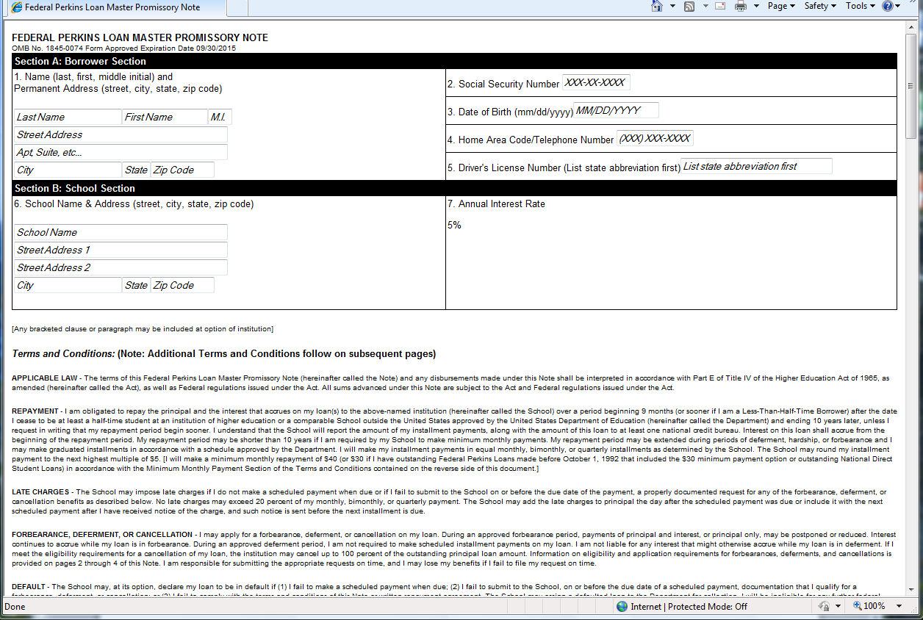
Image 1.B -- Perkins Electronic Master Promissory Note

Image 1.B displays more Terms and Conditions as well as the eSign Section of the Perkins eMPN.

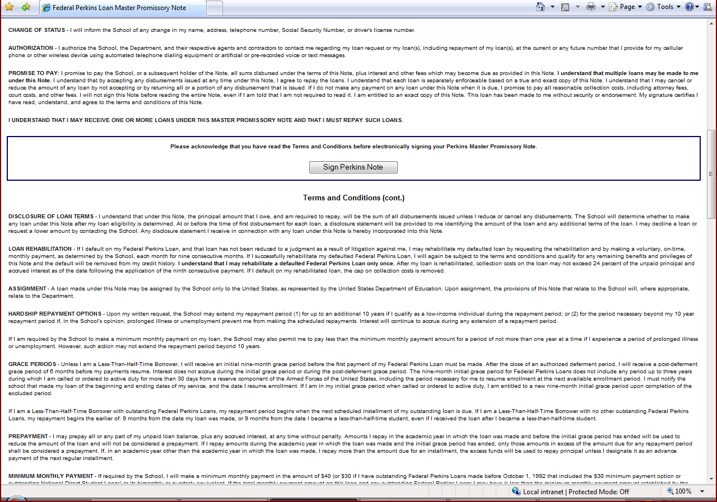
Image 1.C – Important Notice Section

Image 1.C displays the part of the Important Notice section which follows the remaining Terms and Conditions (not displayed).

