Number 63 | March 2019
Summary
This newsletter describes recent enhancements for school users to the National Student Loan Data System (NSLDS®) Professional Access website. These changes include:
- Enrollment Reporting Enhancements
  - Enrollment Reporting Edits
  - New Enrollment Reporting (ER) Supplemental Submittal File
  - Enhancements to Enrollment Update Advanced Search Options
- Previously Retrieved Borrower Search
Enrollment Reporting Enhancements

Enrollment Reporting Edits
Enrollment Reporting edits have been relaxed to allow schools to account for the following situations found in enrollment rosters:
- Program-level enrollment data with an invalid or future Program Begin Date
- Inconsistencies between Credential Level and Special Program Indicator
(e.g., ‘A’ Selective Admission Associate Degree Program is not reported with Credential Level ‘02’)
Prior to this change, schools were presented with error code 66 (for Program Begin Date) and/or 67 (for Credential Level and Special Program Indicator) when correcting enrollment data. Now schools may report an Enrollment Status of ‘X’ (Never Attended) or ‘Z’ (No Record Found) in these situations.

New Enrollment Reporting (ER) Supplemental Submittal File
Over the years, schools have asked for the option to provide NSLDS with enrollment reporting file updates outside of their normal reporting schedule. While NSLDS offers online updates to enrollment reporting, schools requested a method to provide ad hoc updates through the normal file submission process. In response to these requests, we are pleased to announce the Enrollment Reporting Batch Process has been enhanced to accept an Enrollment Reporting (ER) Supplemental Submittal file. The new ER Supplemental Submittal file provides schools with the option to report outside of their established NSLDS roster schedule. The Supplemental file will allow schools to provide off-schedule updates aligned with their academic calendars (e.g., Graduations, late registration, and add or drop deadline dates).
NSLDS processes the ER Supplemental Submittal file in the same manner as the existing Enrollment Reporting file with two exceptions. First, a school must indicate an ER Supplemental Submittal file by entering ‘NSLDS ENRL SUPPLEMENTAL’ in the Header Label field and ‘S’ in the File Type of the Enrollment Reporting File Header Record, as shown in the fixed-width Enrollment Reporting File Header Record layout below. Second, the ER Supplemental Submittal file will not generate an Error/Acknowledgement file. The ER Supplemental Submittal file can be submitted in both fixed-width and comma-separated values (CSV) file format.
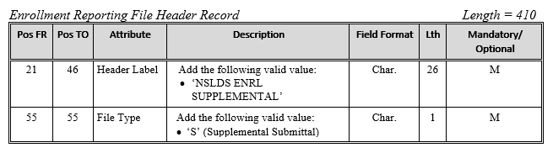
Although an Error/Acknowledgement file is not returned, schools may confirm receipt of the ER Supplemental Submittal file on the Enrollment Submittal Tracking page. Access the Enrollment Submittal Tracking page via the Enrollment Reporting Profile page under the Enroll Tab of the NSLDS Professional Access website (see example below). Since errors are excluded from the Error/Acknowledgement file, data in the following Submittal Detail fields are displayed as ‘N/A’:
- Valid Bundles
- Bundles in Error
- Percent Valid
- Campus Records
- Program Records
- Email Records
- Unique Borrowers

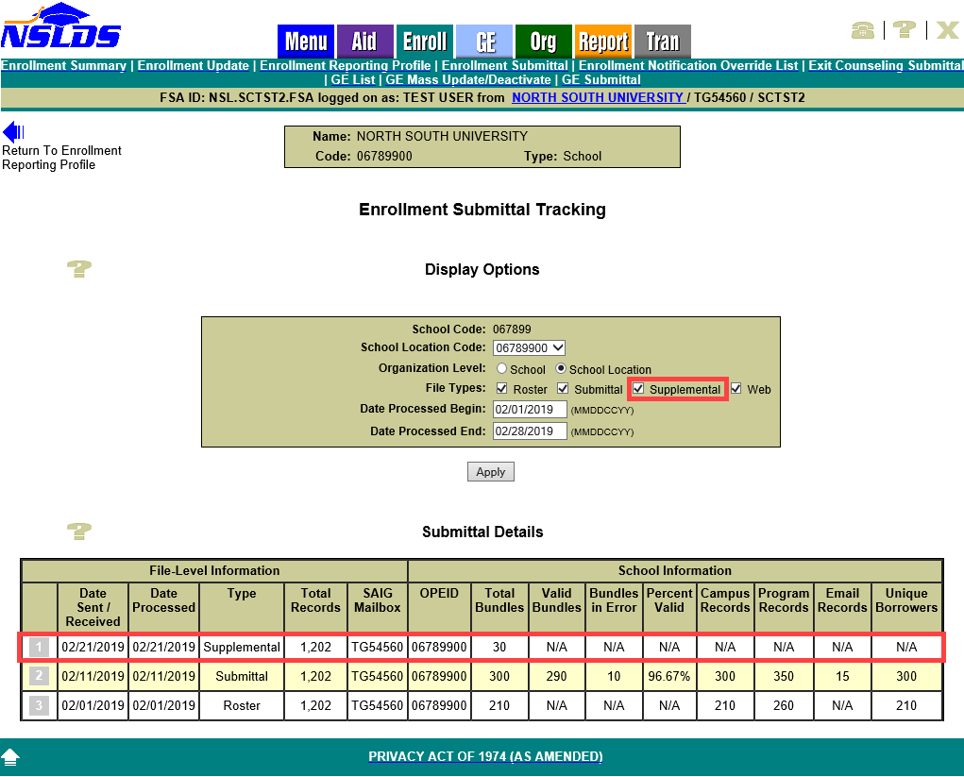
Additionally, students and programs certified as a result of an ER Supplemental Submittal file are included in the Enrollment Reporting Statistics calculation, while the errors are not. ER Supplemental Submittals are not reflected in the counts of Roster Records Returned or Roster Records in Error Returned and are excluded from the Roster Error Percent calculation.
It is important to note the ER Supplemental Submittal file is not a replacement for responding to an Enrollment Roster and does not replace existing Enrollment Rosters or reporting requirements. As a reminder, Enrollment Rosters are to be returned within 15 days of the date that NSLDS sends a roster file to the school or its third-party servicer. If a school only reports using the ER Supplemental Submittal file, they will receive Late Roster Notifications as a reminder of their obligation to complete and return the Enrollment Roster to NSLDS within 15 days of receipt.
Refer to the NSLDS Enrollment Reporting Guide, Appendix A-1 and A-2 for more information about Enrollment Reporting Statistics, the Enrollment Reporting Roster File Record Layouts, and Reporting Instructions.

Enhancements to Enrollment Update Advanced Search Options
New advanced search options have been added to the Enrollment Update page under the Enroll Tab of the NSLDS Professional Access website. The new advanced search options give schools a more simplistic ways of searching at the program level, rather than at the campus level enrollment.
The following advanced search options have been added to the Enrollment Update page:
- Classification of Instructional Program (CIP) Code
- Credential Level
- Published Program Length in Years
- Special Program Indicator

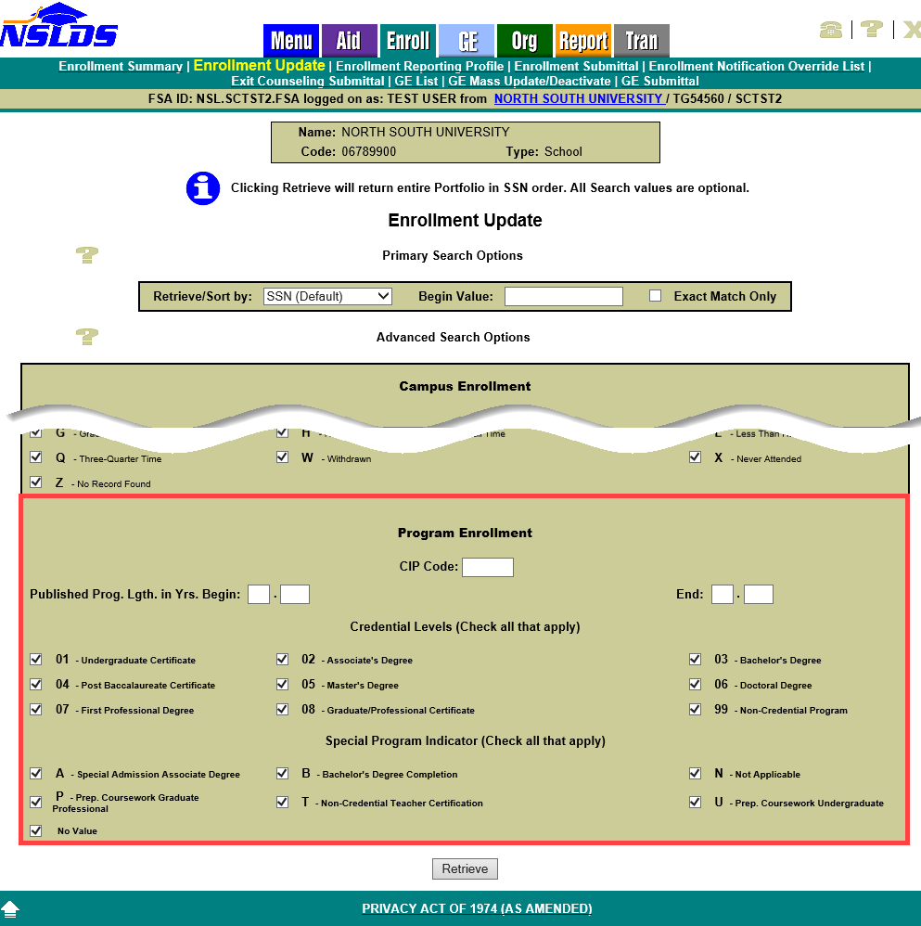

A student’s enrollment is always certified at the school location by the bundle. As a result, when the program-level advanced search options are used for a particular program for a student at a given location, the results on the Enrollment Maintenance page will display the student’s campus-level enrollment, as well as any other programs for the student that currently appear on that location’s Enrollment Reporting roster.
Previously Retrieved Borrower Search
The NSLDS Professional Access website has been enhanced to include the new Previously Retrieved Borrower search. This new functionality allows school users to select from a list of up to twenty borrowers the user has previously viewed. The most recently retrieved borrower will appear first in the list.
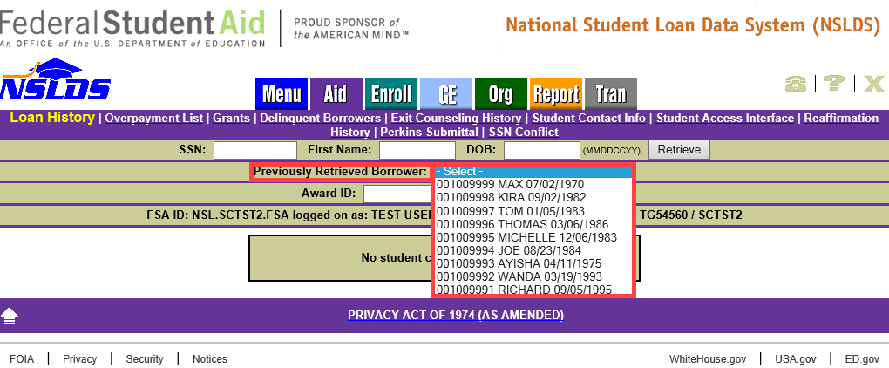
When a borrower is selected from the list, the borrower’s three identifiers (SSN, First Name, and DOB) autofill in the search boxes above. Click retrieve to view that individual’s information.
The Previously Retrieved Borrower search option is available on the following pages of the NSLDS Professional Access website:
- Loan History
- Overpayment
- Grant
- Exit Counseling
- Student Contact Information
- Student Access Interface
- Reaffirmation History
- Enrollment Summary
- Enrollment Detail
- Program Enrollment Detail
- Enrollment Timeline
- Subsidized Usage
- Maximum Eligibility Timeline
Customer Service Reminder
Please remember to keep your NSLDS Professional Access website ORG contacts current and always list at least a Primary Contact for your organization. It is important to include a Customer Svc (Borrowers) contact as the information is displayed on the NSLDS Student Access website and may be viewed by borrowers and other Federal Student Aid partners.
The NSLDS Customer Support Center at 1-800-999-8219 is available Monday through Friday from 8 a.m. to 9 p.m. Eastern time (ET). You may also contact Customer Support by email at nslds@ed.gov. Callers in locations without access to 800 numbers may call 785-838-2141.

