Number 59 | December 2017
Summary
This newsletter describes a new National Student Loan Data System (NSLDS®) report to assist schools with understanding which students are included in their Enrollment Reporting Statistics. The new Enrollment Reporting Statistics Backup Detail Report, now available on the NSLDS Professional Access website, is described below.
NSLDS Enrollment Reporting Statistics Backup Detail Report

Enrollment Reporting Statistics Backup Detail Report
The new Enrollment Reporting Statistics Backup Detail Report (SCHCB1) allows school users to request an extract that lists the students included in the most recently calculated Enrollment Reporting Statistics. Schools may use this report to identify which individual students were not counted as reported with program enrollment information for the latest Enrollment Reporting Statistics calculation. These students caused the Enrollment Reporting Statistic to be lower. Schools with lower than expected program enrollment percentages may research these students to determine if they should have been reported with program enrollment information.
Please note the following specific information about the report:
- Students who were on the school’s roster as of the Start Date, and who were included in the denominator of the Percent Certified with Program Enrollment calculation, are listed on the report.
- The Student Certified with Program Enrollment indicator field identifies those students that were included in the Percent Certified with Program Enrollment calculation’s numerator, meaning that they were successfully certified with program enrollment information at least once during the evaluation period (Start Date to Evaluation Date).
- The report also identifies students included in the numerator due to ED-approved exceptions, for example, students certified with an enrollment status of X – Never Attended, or Z – No Record Found. As a reminder, an enrollment status of X or Z does not affect the Enrollment Reporting Statistics.
The new Enrollment Reporting Statistics Backup Detail Report is available in the Report List on the Report tab of the NSLDS Professional Access website. The school may choose to receive all data for all locations associated with their six-digit OPEID by leaving the asterisk (*) in the School Location Code field, or only data for a single location by entering the eight-digit OPEID for that location. The report is available with Extract Type options of Comma Separated Values (CSV) and Standard (Fixed-width) and the user may choose a Sort By option of SSN or Last/First Name. The output is delivered to the Student Aid Internet Gateway (SAIG) mailbox (TG number) associated with the FSA User ID that requested the report, using message class ERSBCDOP for CSV or ERSBFWOP for Fixed-width.
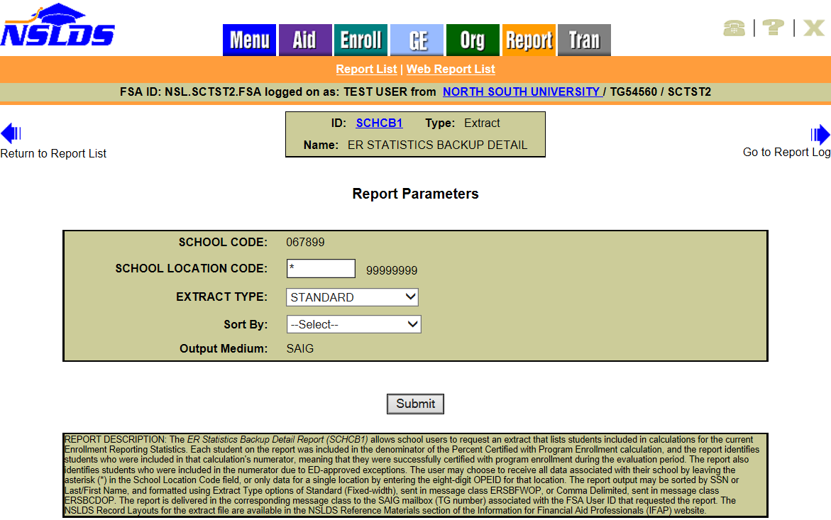
The file layout for this new report is available in the NSLDS Record Layouts section of the Information for Financial Aid Professionals (IFAP) website.
An example of the report that has been imported into a spreadsheet with columns labeled is provided below. The Student Certified with Program Enrollment Indicator signifies that the student was included in the numerator when marked with a ‘Y’, and the Numerator Exception Indicator notes where exceptions, mentioned previously, apply.
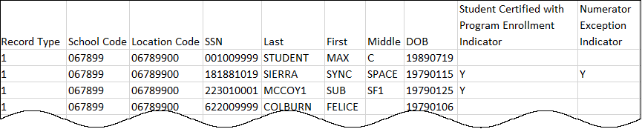
Please note that the new report can only provide data for the most recently calculated Enrollment Reporting Statistic. The Enrollment Reporting Statistics are displayed under the Enrollment Reporting Profile page of the NSLDS Professional Access website.
Reminder: Enrollment Reporting Statistics are calculated during the third week of each month. Only students who were on the school’s enrollment reporting roster as of the Start Date for the evaluation period are included in the calculation. The Start Date is 135 days prior to the Evaluation Date.
Please refer to the NSLDS Enrollment Reporting Guide for more information about Enrollment Reporting Statistics, and for information about other tools and reports that are available to assist schools with Enrollment Reporting. The NSLDS Enrollment Reporting Guide is available in the NSLDS User Documentation section of the IFAP website.
Customer Service Reminder
Please remember to keep your NSLDS Professional Access website ORG contacts current and always list at least a Primary Contact for your organization. It is important to include a Customer Svc (Borrowers) contact as the information is displayed on the NSLDS Student Access website and may be viewed by borrowers and other Federal Student Aid partners.
Additionally, please ensure your school has an Enrollment Reporting contact listed so important notifications related to enrollment reporting compliance are received.
The NSLDS Customer Support Center at 1-800-999-8219 is available Monday through Friday from 8 a.m. to 9 p.m. Eastern time (ET). You may also contact Customer Support by email at nslds@ed.gov. Callers in locations without access to 800 numbers may call 1-785-838-2141.

