Number 55 | August 2016
Summary
This newsletter describes recent enhancements for school users to the National Student Loan Data System (NSLDS) and to the NSLDS Professional Access Web site. These changes include:
- Enrollment Reporting Enhancements
  - Updates to Enrollment Update and Enrollment Maintenance
  - New Program Length Reasonability Edits
  - Other Edit Enhancements
  - Updates to Enrollment Push To Roster
  - Enrollment Reporting Compliance Report
  - Display of Compliance Notification Icon
- School Portfolio Report Import Tool Enhancements
- Perkins Spreadsheet Submittal Format Template Now Available
Enrollment Reporting Enhancements

Updates to Enrollment Update and Enrollment Maintenance
The Enrollment Update and Enrollment Maintenance pages have been updated to include new student selection criteria, sort options, and new warning icons. Also, a count of the number of students selected by the search has been added.
On the Enrollment Update page, schools can now filter results to display students needing to have program enrollment information reported by checking the box next to Exclude Students with Certified Programs. This will allow schools to select only students that either have no reported programs, or who have new programs reported to NSLDS by the Common Origination and Disbursement (COD) System that need to be certified by the school. This will help schools improve their Enrollment Reporting Statistics.
The Retrieve/Sort by options have been enhanced to allow users to display students with oldest Certification Dates first. Many schools have students in their portfolio that have not been certified for months or even years. These students negatively affect the enrollment statistics and should be certified with an updated or final status. As a reminder, schools may also use the new Late Enrollment Certifications Report to identify these students. See NSLDS Newsletter 53 for information about this report.

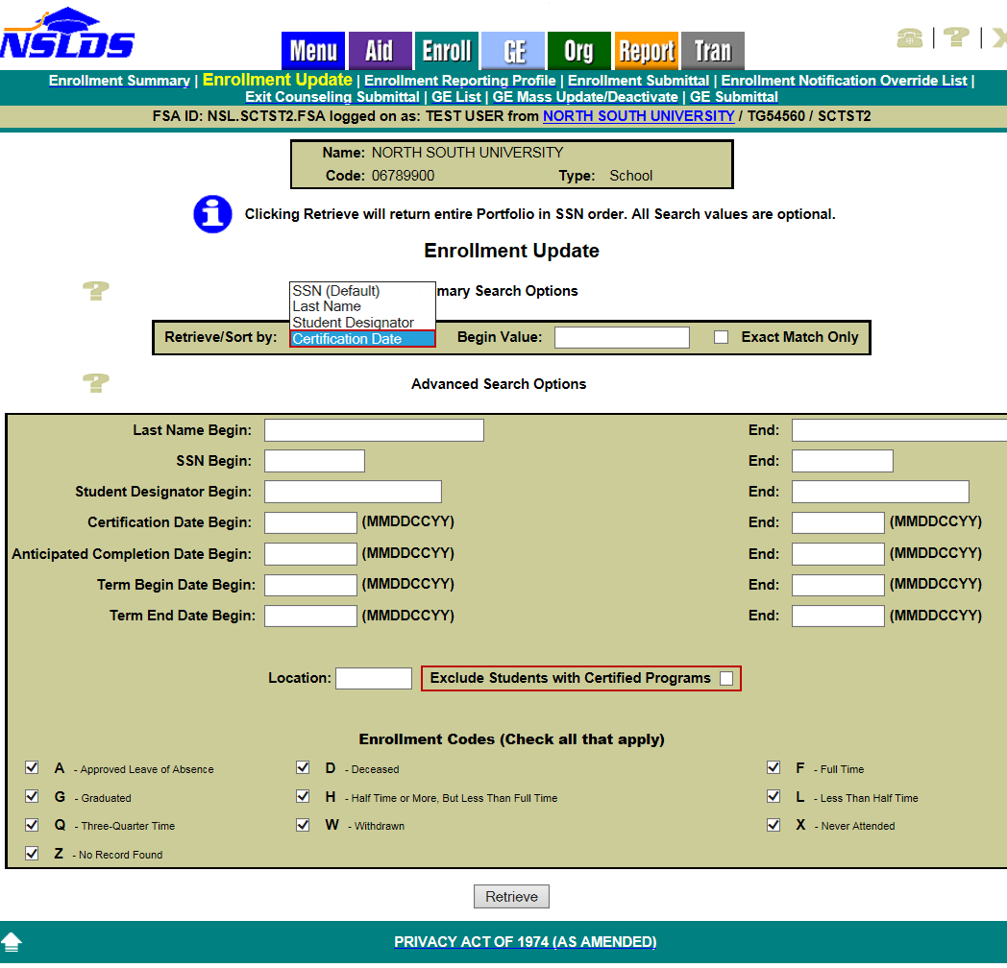
On the Enrollment Maintenance page, the Retrieve/Sort by options have also been enhanced to allow sorting by Certification Date (oldest first). If a school has students who have not been certified in more than 65 days, a warning icon reading Late Certification will appear at the top of the page. In addition, a warning icon will appear next to each student that has not been certified in over 65 days. While the Certification Date edit has been relaxed (see below), schools are still required to report enrollment for all students at least every two months, so this will help identify students needing to be certified.
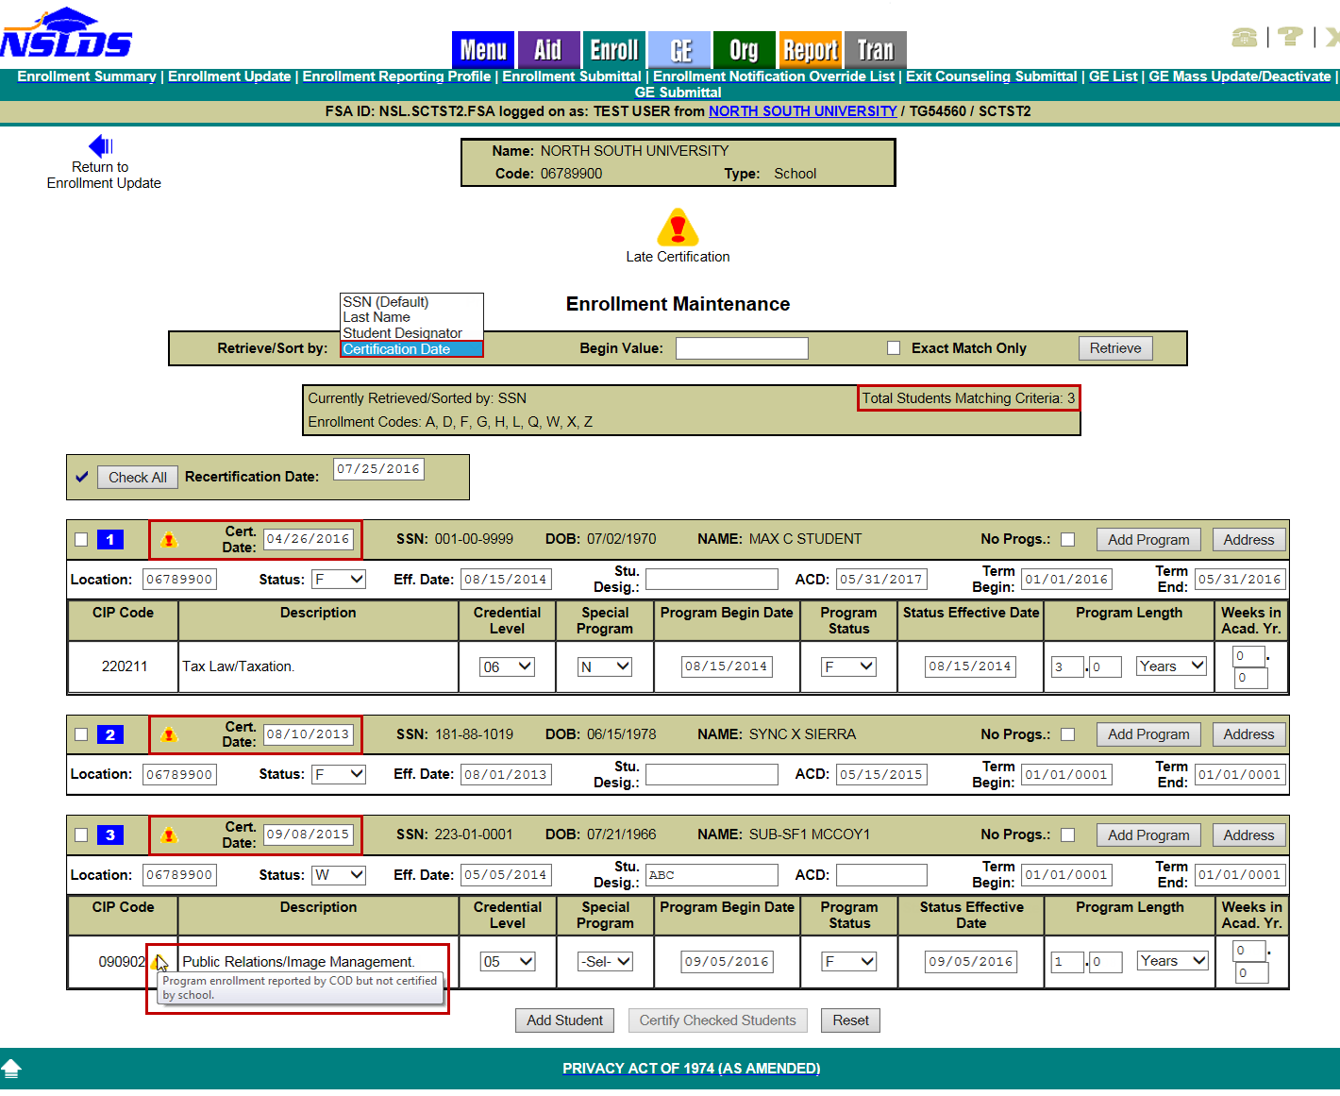
If a student has a new program that has been reported to NSLDS by the COD System but has not been certified by the school, a warning icon will appear next to the CIP code for that program.
Finally, a new field has been added, Total Students Matching Criteria, which shows the number of students returned by the search options the school selected on the Enrollment Update page.
New Program Length Reasonability Edits
New edits have been added to ensure accurate program-level reporting. Error 77 is used if the reported Published Program Length (converted to years if reported in Weeks or Months) is too short for the associated Credential Level. Error 78 is used if the reported Published Program Length is too long for the associated Credential Level. The minimums and maximums for Published Program Length, in years, for each associated Credential Level are shown in the chart below.
We consider these program length edits to be very generous for most credential levels, and do not expect that many programs should be reported at or near these minimums or maximums. The edits were set to identify incorrect reporting, which may harm borrowers under the 150% Direct Subsidized Loan Limit. We will continue to review the program data and may adjust these edits in the future.

Credential Level | Credential Level Description | Minimum Years  > or = | Maximum Years  < or =
01 | Undergraduate Certificate or  Diploma Program | 0.1 | 10
02 | Associate's Degree | 0.4 | 10
03 | Bachelor's Degree | 0.9 | 10
04 | Post Baccalaureate Certificate | 0.4 | 10
05 | Master's Degree | 0.4 | 12
06 | Doctoral Degree | 0.9 | 12
07 | First Professional Degree | 0.2 | 10
08 | Graduate/Professional Certificate | 0.2 | 10
99 | Non-Credential Program  [Preparatory Coursework/  Teacher Certification] | 0.1 | 10
Additionally, Error 79 is used if the reported Program Begin Date is too far in the past.
Schools are reminded to report traditional programs in Years rather than in Months. For example, report a four year program as 4 years, not as 48 months. When program length is reported in months or weeks, NSLDS uses this value along with the “Weeks in Academic Year” value to calculate a program length in years. This can result in program lengths that are too long. Refer to 150% Direct Subsidized Loan Limit: Electronic Announcement #22 for more information about the proper reporting of Program Length, and how to correct errors.
Note that any errors will lower a school’s Enrollment Reporting Statistics percentage if they are not corrected in a timely manner. Schools (or their servicers) must correct and resubmit all errors within 10 days.
Other Edit Enhancements
In response to school concerns about certifying enrollment during the summer for students who are not actually attending classes, NSLDS has relaxed Edit 38 – Certification Date is too Old. The edit has been modified to allow certification dates up to 135 days in the past. This will allow schools to meet the requirement to report enrollment at least every 60 days, while also following the Continuous Enrollment guidance, by reporting the student’s last spring status (and certification date) through the summer, if the student is expected to return in the fall (or after another non-required period of attendance).

NSLDS has also modified the Enrollment Reporting Statistics calculation so any program enrollment reporting with a certification date accepted under this modified edit will be included and counted towards the school’s percentage of students reported with Program Enrollment. Schools will notice that the “Start Date” on the Enrollment Reporting Statistics page is now 135 days prior to the “Evaluation Date”. This should not negatively affect a school’s statistics and in many cases could slightly increase the school’s percentage.

Updates to Enrollment Push To Roster
The Enrollment Push To Roster page has been updated to include an Enrollment Push Date. The student will be added to the school portfolio on the Enrollment Push Date and appear on the next school roster generated after that date. The date can be a future date, but cannot be more than 18 months greater than the current date.
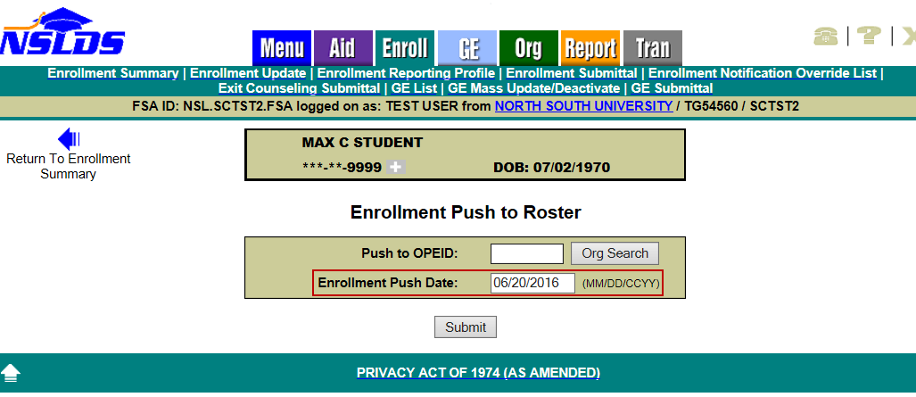
Enrollment Reporting Compliance Report
In anticipation of the future distribution of Enrollment Reporting Compliance Letters, based on the enrollment statistics, the new Enrollment Reporting Compliance Report (SCHCR1) allows authorized school users to view the distribution history of the Compliance Letters and the enrollment statistics content sent to schools. The report can be requested on the Report tab of the NSLDS Professional Access Web site under Web Report List. Schools can request the report for a six-digit school code or for an eight-digit school location code. When requesting the report, the user must indicate the Letter Sent On or After/On or Before date range that corresponds to the date the letter, or letters, were sent to the school. The report output is displayed on-demand in a browser window using MS Excel format.
Note: Compliance Letters will be sent in the coming months. Schools who request the new Enrollment Reporting Compliance Report will receive an empty report output until after we begin distributing Compliance Letters.
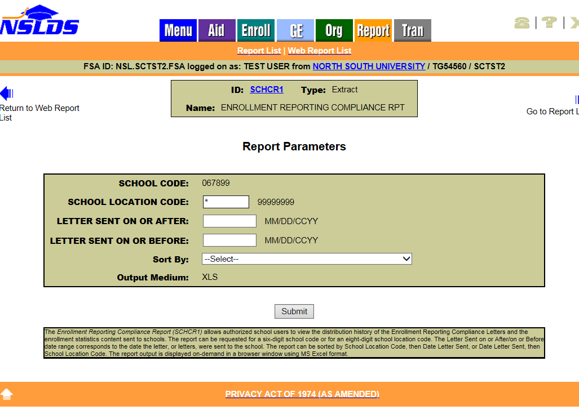
Display of Compliance Notification Icon
A new Compliance Notification icon has been added to the Enrollment Reporting Statistics page of the NSLDS Professional Access Web site. The Compliance Notification icon informs schools about Enrollment Reporting Compliance Letters sent to an individual school location (location view) or all the locations at the school (school view).
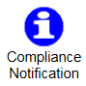
The Compliance Notification icon will display if no letters are available, to confirm the absence of a letter history. The icon will also display if there are additional Compliance Letters not displayed on the page, as an alert to the school.
As noted in the previous section, distribution of Compliance Letters has not yet begun.

School Portfolio Report Import Tool Enhancements
The NSLDS School Portfolio Report Import Tool has been updated to include the fields added to NSLDS in support of the new repayment options discussed in NSLDS Newsletter 52:
- First Payment Due Date
- Cumulative Total Payment Amount
- Next Payment Due Date
- Most Recent Payment Effective Date
- Income-Driven Repayment Plan Anniversary Date
The tool can be used to easily load data generated from the comma separated values (CSV) extract version of the School Portfolio Report (message class SCHPR1) into the Microsoft Excel spreadsheet application, and is designed to assist schools with reviewing and analyzing their School Portfolio Report extract files. Please refer to the electronic announcement dated June 22, 2015 for more information about the tool.
To download the School Portfolio Report Import Tool, go to the Default Prevention Resource Information page. The School Portfolio Report Import Tool can be found in the “Default Prevention Resources – Reducing Default Risk” box in the middle of the page. Instructions for using the tool are provided on the first tab of the workbook.
Perkins Spreadsheet Submittal Format Template Now Available
As described in NSLDS Newsletter 53, functionality has been added to assist schools in submitting Federal Perkins Loan data to NSLDS. Schools (and Perkins Loan servicers acting on behalf of schools) may choose to use the new Perkins Spreadsheet Submittal process to report loans not previously reported to NSLDS, report updates to loans currently found on NSLDS, or assist in closing loans in their portfolio. To ensure the data in the spreadsheet is correctly completed for submission, we have posted the Perkins Spreadsheet Submittal Format Template (in Excel format) and Submittal Instruction Guide on the Federal Student Aid Download (FSADownload) Web site, in the “Software and Associated Documents” section. Refer to the Instruction Guide for more information.
Customer Service Reminder
Please remember to keep your NSLDS Professional Access Web site ORG contacts current and always list at least a Primary Contact for your organization. It is important to include a Customer Svc (Borrowers) contact as the information is displayed on the NSLDS Student Access Web site and may be viewed by borrowers and other Federal Student Aid partners.
Additionally, please ensure your school has an Enrollment Reporting contact listed so important notifications related to enrollment reporting compliance are received.
The NSLDS Customer Support Center at 800/999-8219 is available Monday through Friday from 8 A.M. to 9 P.M. (ET). You may also contact Customer Support by e-mail at nslds@ed.gov. Callers in locations without access to 800 numbers may call 785/838-2141.

