Number 52 | March 2016
Summary
This newsletter describes recent enhancements for school users to the National Student Loan Data System (NSLDS®) and to the NSLDS Professional Access Web site.
These changes include:
- Enhancements to Student Eligibility
- Inclusion of the Reaffirmation Indicator
- Updates to Unusual Enrollment History (UEH)
- Payment/Repayment Data on NSLDS Professional Access Web Site
  - Payment/Repayment Data on Loan Detail Page
  - Revised Pay As You Earn (REPAYE) Codes
Note: The changes described in this newsletter are also reflected on the NSLDS Student Access Web site and in NSLDS MyStudentData Download functionality, where applicable.
Enhancements to Student Eligibility

Inclusion of the Reaffirmation Indicator
As described in the NSLDS Transfer Student Monitoring/Financial Aid History Processes and Batch File Layouts for 2016-2017 (published November 24, 2015), beginning with the 2016-2017 Award Year, the Reaffirmation Indicator has been added to the Transfer Student Monitoring and Financial Aid History reports to assist schools with monitoring students’ continued eligibility for Title IV federal student aid. The indicator will inform schools when a reaffirmation has been reported to NSLDS and may be relied upon to determine the student's eligibility.
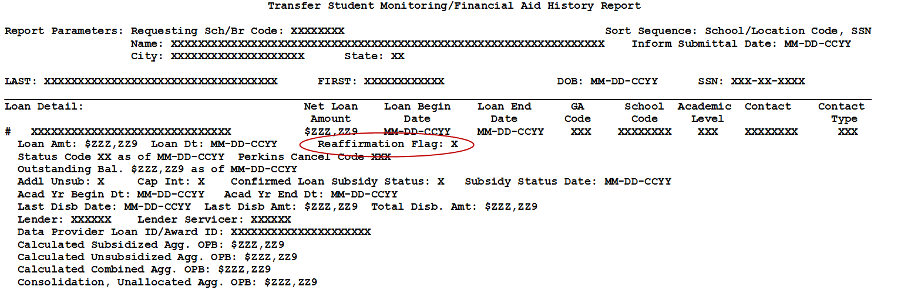

Updates to Unusual Enrollment History (UEH)
Changes have been implemented to assist schools in their UEH administrative and research efforts.
When determining UEH, NSLDS now considers whether a school has had a change of affiliation causing an OPEID to change. In those cases, NSLDS will consider the multiple school codes as the "same" school despite having a different 8-digit OPEID for the UEH evaluation.
Additionally, NSLDS now reviews undergraduate and graduate status independently over the previous four award years. During this monitoring period, undergraduates will be assessed if they have received Pell Grants and/or loans from multiple schools. Graduate students will be evaluated if they have received loans from multiple schools. If a student is in both groups, the highest (worst) UEH value from either group will be pushed to the applicant’s ISIR.
The enhancements to UEH evaluation began in January 2016 and became effective for all 2016-2017 ISIRs. For the 2015-2016 Award Year, the UEH updates were applied as a mid-year change. For additional information and processing notes, review the Electronic Announcement posted on January 20, 2016.
Payment/Repayment Data on NSLDS Professional Access Web Site

Payment/Repayment Data on Loan Detail Page
We have made several enhancements to the Loan Detail page on the NSLDS Professional Access Web site.
First, the Last Payment Date has been replaced with Next Payment Due Date in order to provide users with more useful data.
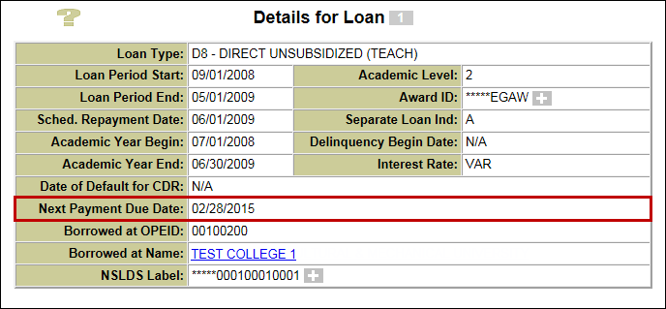
Under Activities for Loan on the Loan Detail page, Repayment Plan Date Entered has been relabeled as Disclosure Date. The Disclosure Date is the date on which the servicer distributed the disclosure of repayment terms to the borrower for the loan. This date will change each time the repayment terms change.
Additionally, two new fields have been added to provide more information pertaining to the loan’s repayment:
- 1st Payment Due Date—first payment due on the loan following the disclosure date. This date will change each time the repayment terms change.
- IDR Payment Anniv. Date—date a borrower will be reevaluated for an Income Driven Repayment (IDR) plan. This date is based on the date when the borrower entered the IDR plan or the date when the borrower requested that the servicer recalculate the IDR payment amount earlier than the anniversary date.
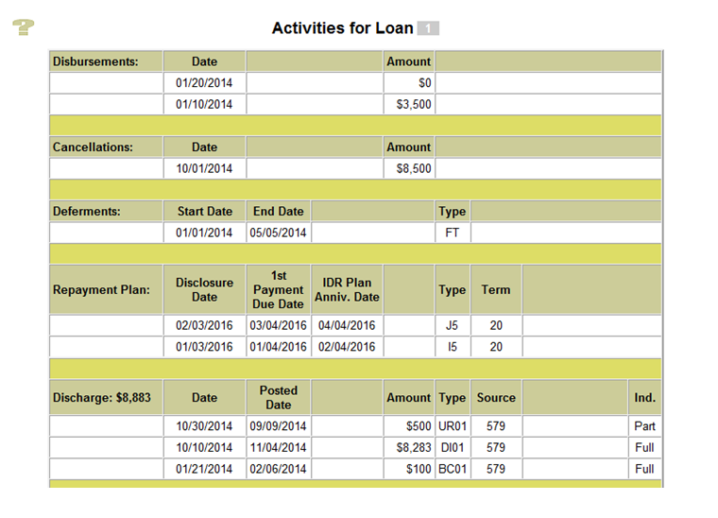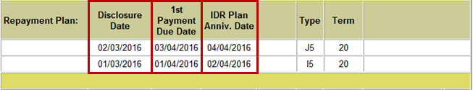
Another change to the Activities for Loan section includes identifying if a discharge or forgiveness is the full amount of the loan or a partial amount:
- Discharge Partial/Full Indicator—indicates if the discharge record reported is a partial or a full discharge of the loan
- Forgiveness Partial/Full Indicator—indicates if the forgiveness record reported is a partial or a full forgiveness of the loan

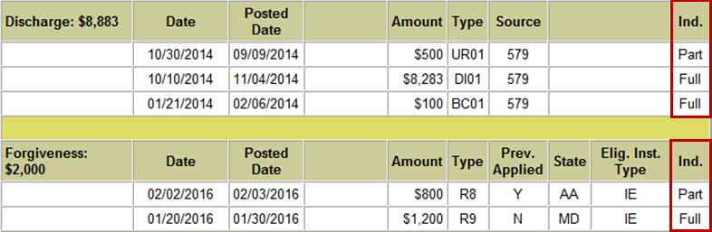
Finally, the Loan Detail page will now display summarized payment data:
- Most Recent Payment Date—date when the latest payment was received or effective date of payment adjustments
- Cumulative Amount Paid—cumulative amount paid on a loan as of the most recent payment date

Revised Pay As You Earn (REPAYE) Codes
Revised Pay As You Earn (REPAYE) is a new repayment plan that will now appear on the Loan Detail page under Activities for Loan. REPAYE is available to Direct Loan borrowers for loans other than Direct PLUS Loans for parents and Direct Consolidation Loans that repaid PLUS loans for parents. The monthly payment amount under the REPAYE repayment plan is 10% of discretionary income. Under REPAYE, borrowers who only have loans received as an undergraduate student are eligible for forgiveness after 20 years of qualifying repayment, and borrowers with any loans received as a graduate or professional student are eligible for forgiveness after 25 years of qualifying repayment. For more information about the REPAYE repayment plan, refer to the December 17, 2015 Electronic Announcement.
NSLDS will now display the following new REPAYE Repayment and Forgiveness codes:
- Repayment Plan Types:
  - I5—borrowers in REPAYE
  - J5—borrowers that have been removed from REPAYE and placed on a Post-REPAYE-Alternative-Fixed repayment plan
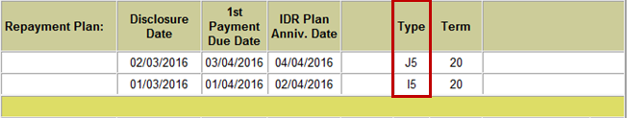
- Forgiveness Types:
  - R8—borrowers eligible for forgiveness under REPAYE after 20 years
  - R9—borrowers eligible for forgiveness under REPAYE after 25 years
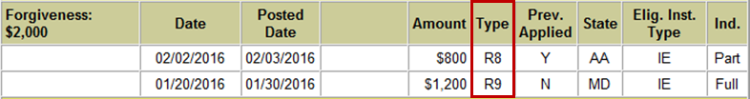
Customer Service Reminder
Please remember to keep your NSLDS Professional Access Web site ORG contacts current and always list at least a Primary Contact for your organization. It is important to include a Customer Svc (Borrowers) contact as the information is displayed on the NSLDS Student Access Web site and may be viewed by borrowers and other Federal Student Aid partners.
Additionally, please ensure your school has an Enrollment Reporting contact listed so important notifications related to enrollment reporting compliance are received.
The NSLDS Customer Support Center at 800/999-8219 is available Monday through Friday from 8 A.M. to 9 P.M. (ET). You may also contact Customer Support by e-mail at nslds@ed.gov. Callers in locations without access to 800 numbers may call 785/838-2141.

