Number 51 | February 2016
Summary
This newsletter describes recent enhancements to the National Student Loan Data System (NSLDS®) and the NSLDS Professional Access Web site.
These changes include:
- Enhancements to Cohort Default Rate (CDR) Reports
  - CDR Notification Letter Report (DRCNL1)
  - School Cohort Default Rate History Report (DRC035)
- Enhancements to Enrollment Reporting
  - Availability of Program Enrollment Detail Online
  - Availability of Enrollment Submittal Tracking Online
  - New NSLDS Enrollment Submittal File Tracking Report
  - Enhancements to Enrollment Reporting Statistics
- Compliance with Program-level Enrollment Reporting Requirement
Enhancements to Cohort Default Rate Reports

CDR Notification Letter Report (DRCNL1)
Schools that are not signed up to receive the eCDR package via the Student Aid Internet Gateway (SAIG) Enrollment Web site or schools that want a replacement copy of their CDR Cover Letter can now request it from the Report tab on the NSLDS Professional Access Web site. The new CDR Notification Letter Report (DRCNL1) allows school users to request their school’s CDR Notification Letter by entering in the Cohort Year and selecting the Rate Type. For example, to request the Draft Rate letter for cohort fiscal year 2012 (October 1, 2011 to September 30, 2012) enter “2012” for the Cohort Year and choose “Draft” as the Rate Type. The report (message class SHDRLROP) is sent to the SAIG mailbox associated with the NSLDS User ID that made the request.
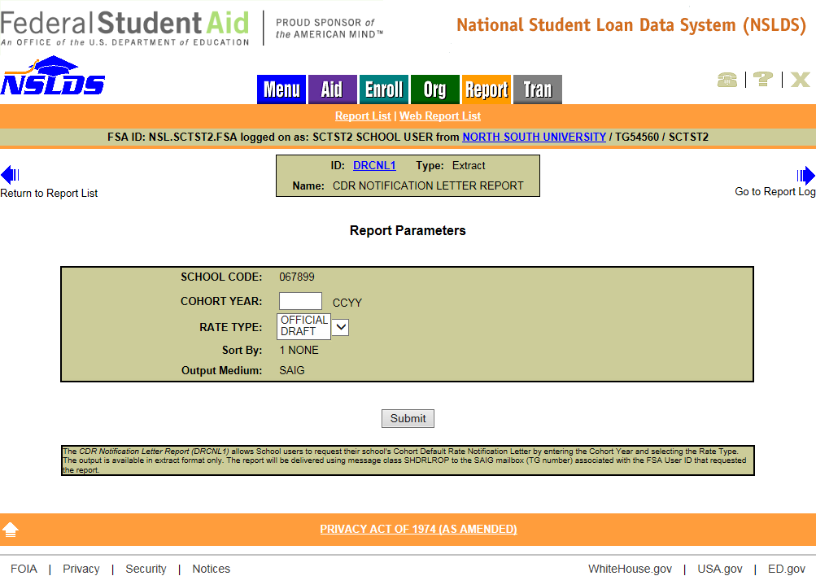

School Cohort Default Rate History Report (DRC035)
The Cohort Default Rate History Report (DRC035) mimics the electronically transmitted eCDR Loan Record Detail Report (LRDR). The available formats for this report have now been expanded to allow school users to request the report in a comma delimited (comma separated values, or CSV) format in addition to the current fixed-width format. The CSV format allows schools to import the report into an Excel spreadsheet. The report, which may be requested on the Report tab, is delivered in message class CDRCSVOP to the SAIG mailbox associated with the NSLDS User ID that requested it.
The file layout for the CSV report is now available in the NSLDS Record Layouts section of the Information for Financial Aid Professionals (IFAP) Web site.
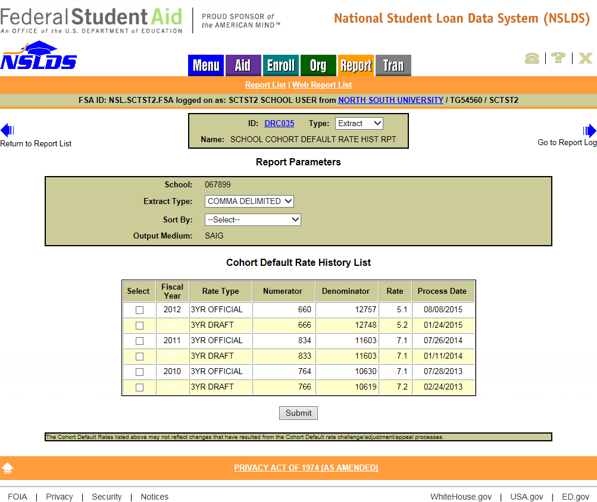
Enhancements to Enrollment Reporting

Availability of Program Enrollment Detail Online
A link to the new Program Enrollment Detail page has been added under the Enrollment Summary page on the Enroll tab, on the NSLDS Professional Access Web site. This page displays detailed history of a student's enrollment status for each program they have attended. A new record is displayed for a program each time the student’s enrollment status for that program changes. Various display and sort options are available to users and are described in detail in the Help Text for this new page (click on the “?” icon at the top right corner of the page).
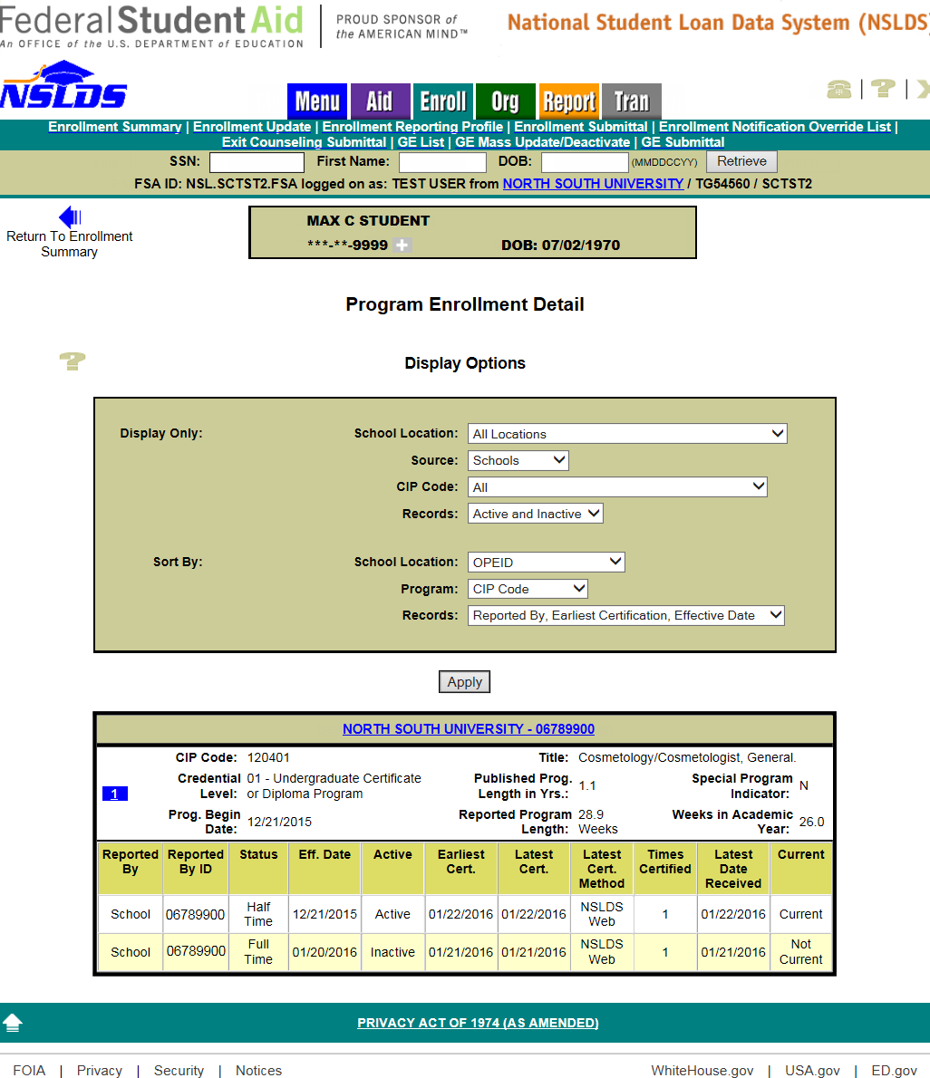
To view information about a school’s individual enrollment reporting certifications for a student’s program, click on the blue number icon. The Program Certification Detail page will appear with information on each certification for a single program status.
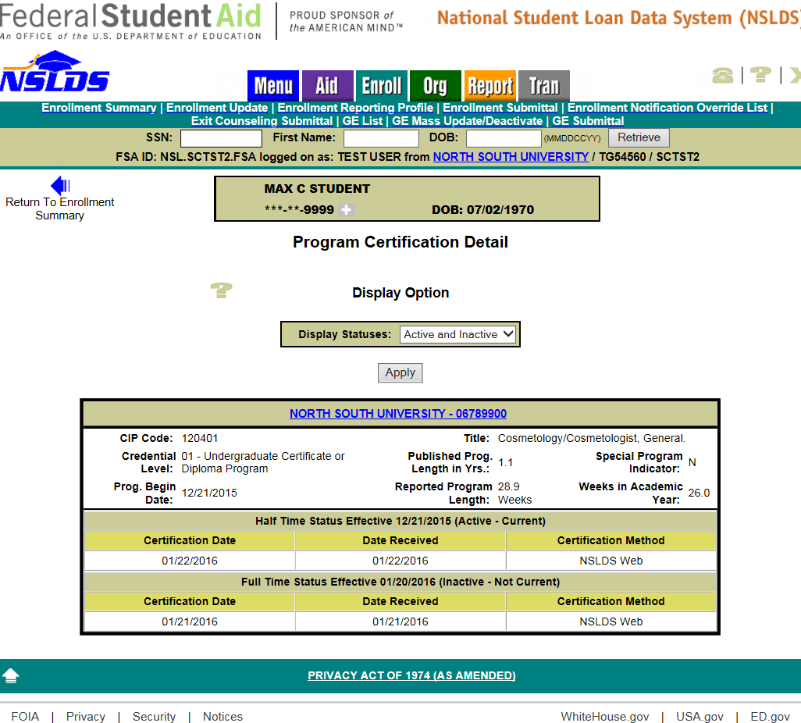

Availability of Enrollment Submittal Tracking Online
A link to the new Enrollment Submittal Tracking page has been added under the Enrollment Reporting Profile page. School users may view information about enrollment rosters and submittals for their own school or for any location at their school. Schools will be able to track enrollment submissions for Rosters (batch files sent from NSLDS to the school/servicer), Submittals (batch files sent from the school/servicer to NSLDS), and Web (includes both online Enrollment Maintenance and Enrollment Spreadsheet Submittal). Note that if the school uses an enrollment servicer, the File-Level Information total records count may include records sent by the school’s servicer for other schools.
Note: Enrollment files processed prior to January 24, 2016 will appear in the Submittal Details section, but will only show a count for Campus Records in the School Information section.
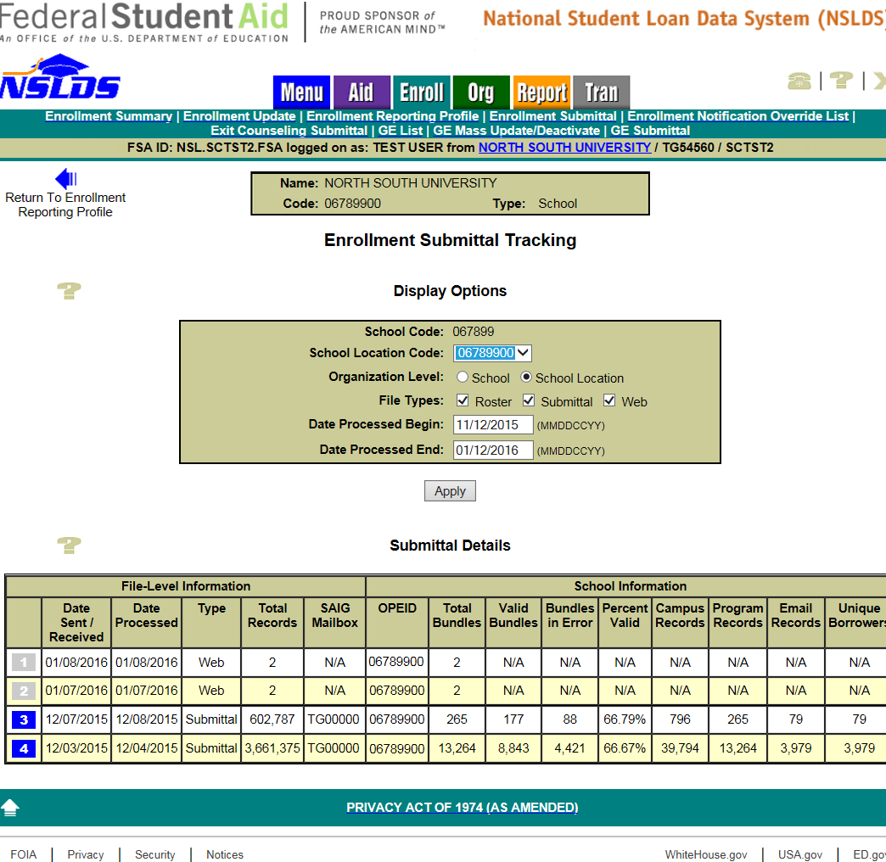

New NSLDS Enrollment Submittal File Tracking Report
The new NSLDS Enrollment Submittal File Tracking Report (SCHET1) allows school users to track enrollment submittal processing for school locations associated with their administration group. The report can be requested on the Report tab for an entire school code or for a single school location code. The enrollment tracking information types that can be selected for inclusion in the report are: Rosters (batch files sent from NSLDS to the school/servicer), Submittals (batch files sent from the school/servicer to NSLDS), Web (includes both online Enrollment Maintenance and Enrollment Spreadsheet Submittal), and/or any combination of the three. At least one type must be selected. The enrollment file tracking information selected can be limited to a date range based on Date Processed. The report output is displayed on-demand in a browser window using MS Excel format.
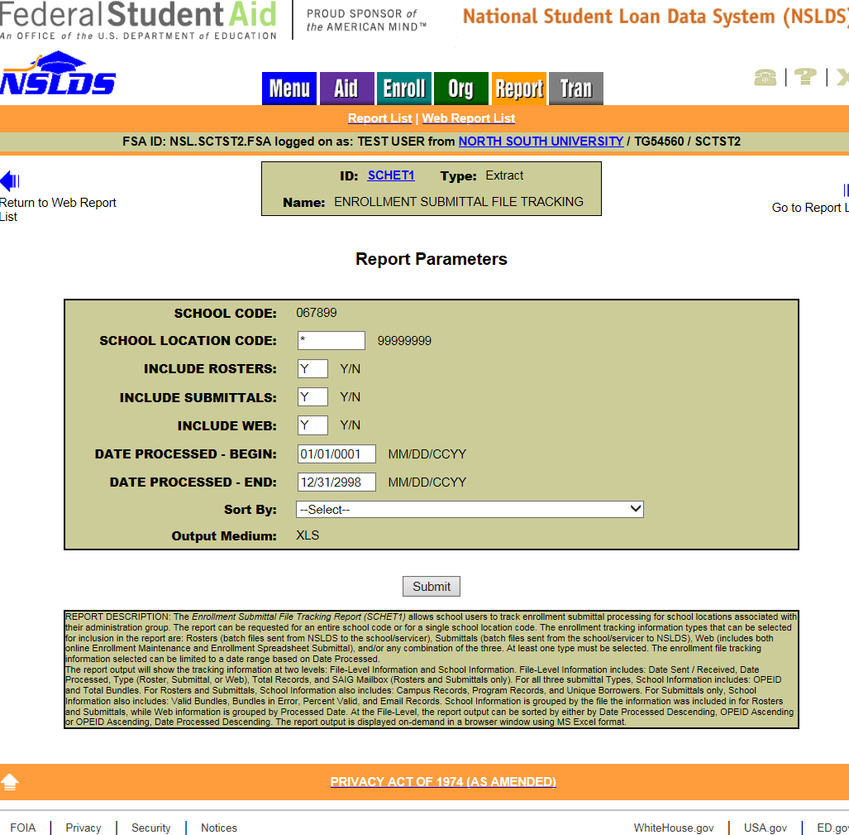

Enhancements to Enrollment Reporting Statistics

We have updated the calculation of the Enrollment Reporting Statistics for enrollment records with a campus-level enrollment status of X (Never Attended) or Z (Record Not Found) with no corresponding program-level data. Reporting of enrollment records with a status of X or Z without corresponding program-level data will no longer negatively impact a school’s Enrollment Reporting Statistics. However, schools should close out any outstanding X and Z status records on their rosters by certifying these records a second time, after which these records will no longer appear on the roster.

In light of this update, we have removed all Enrollment Reporting Statistics information from NSLDS that was calculated prior to January 2016.
Compliance with Program-level Enrollment Reporting Requirement
We will be reinstating the warning icons and messages on the Enrollment Statistics page for schools that are not reporting the required program-level enrollment data at sufficient levels. A school that is reporting program-level enrollment data at a low level will receive a series of escalating warning letters. If the school remains out of compliance, it will be referred to Federal Student Aid’s Program Compliance office for action. We will begin sending these letters to non-compliant schools later this year.
Schools should carefully review their enrollment reporting statistics and take any needed action to ensure that program-level enrollment information is reported for all students that are in programs, which is true for most students.
One common action a school may need to take to ensure compliance is to correct and resubmit records that have been rejected with errors by NSLDS. Rejected records will not be considered certified and will lower a school’s reporting percentage. Schools that use servicers to report enrollment must ensure that the servicer is correcting errors sent by NSLDS to the servicer. Schools can view error counts and error rates on the Enrollment Reporting Statistics page.
Another common action a school may need to take to ensure compliance is to certify for a second time a student’s withdrawn or graduated status. Frequently, schools fail to take this action, and these students remain on the school’s roster file. These students will also lower a school’s reporting percentage statistic. Schools may use the Advanced Search Options on the Enrollment Update page to search for students who have both a specific enrollment status code and who have not been certified since a certain date.
We plan to add additional tools and reports to NSLDS later this year to assist schools with identifying issues and meeting enrollment reporting requirements. Monitor the IFAP Web site for forthcoming communications announcing the availability of these products.
Customer Service Reminder
Please remember to keep your NSLDS Professional Access Web site ORG contacts current and always list at least a Primary Contact for your organization. It is important to include a Customer Svc (Borrowers) contact as the information is displayed on the NSLDS Student Access Web site and may be viewed by borrowers and other Federal Student Aid partners.
Additionally, please ensure your school has an Enrollment Reporting contact listed so important notifications related to enrollment reporting compliance are received.
The NSLDS Customer Support Center at 800/999-8219 is available Monday through Friday from 8 A.M. to 9 P.M. (ET). You may also contact Customer Support by e-mail at nslds@ed.gov. Callers in locations without access to 800 numbers may call 785/838-2141.

