Number 49 | July 2015
Summary
This newsletter describes recent enhancements to the National Student Loan Data System (NSLDS®) and the NSLDS Professional Access Web site. These changes include:
- Enhancements to Enrollment Reporting:
  - Enhancements to Student Address Reporting
  - Correct Reporting of Program Data
  - Availability of Enrollment Reporting Statistics Online
  - New NSLDS Enrollment Statistics Report
- Gainful Employment:
  - Enhancements to Social Security Number Accuracy
  - GE Reporting Deadlines Reminder
Enhancements to Enrollment Reporting

Enhancements to Student Address Reporting
NSLDS now includes student address data from the Common Origination and Disbursement (COD) System and the Central Processing System (CPS) on the NSLDS Enrollment Reporting Rosters if a school has not reported address data for a student. Schools are responsible for validating and certifying the address data.

Additionally, if an address is unknown or not available for a student, report Unknown (“UK”) in any of the address fields (Address Line 1, State, City, Country, and Postal Code). If any of these fields are reported as ”UK”, the address will not be edited or stored. Address Line 2 remains optional and will be stored as spaces if ”UK” is reported. Schools should continue to report ”UK” in future rosters until the address information becomes available.

Correct Reporting of Program Data
The data that identifies a unique program for enrollment reporting now includes the Published Program Length (PPL):

If the PPL reported to the COD System differs from that reported to NSLDS, it will generate a new unique program on NSLDS. Schools need to examine data reported to the COD System and to NSLDS to determine whether the program length was correctly reported, as described in 150% Direct Subsidized Loan Limit: Electronic Announcement #17. To correct the data on NSLDS, report the incorrect program with a program-level status of Never Attended (“X”) and it will be removed from the Enrollment Roster.
Additionally, NSLDS uses the Payment Period Begin Date from the COD System as the Program Begin Date for all program-level enrollment data reported by the COD System. Schools need to correct this date if it is incorrect.
Note that an incorrectly reported program length may inappropriately trigger loss of interest subsidy for the student.

Availability of Enrollment Reporting Statistics Online
A link to the new Enrollment Reporting Statistics page has been added under the Enrollment Reporting Profile page. This page displays information about the completeness and quality of enrollment reporting by schools and school locations participating in the Federal Student Aid programs. School users are able to see summary statistics for their school as a whole or for any of its locations.
The information displayed on each row includes:
- The total number of students in the enrollment portfolio of the school or location as of the Start Date.
- The number and percentage of the students that were certified between the Start Date and the Evaluation Date.
- The number and percentage of the students that were certified with the required program data between the Start Date and the Evaluation Date.
- The total number of roster records returned, the total number of errors, and the error percentage for the period.
A warning icon and message will display under the following conditions:
- The school location has, as of the most recent calculation, failed to achieve the minimum percentage threshold for certifying students with the required program data.
- The school location is currently late in responding to a roster sent by NSLDS. A late letter has been sent and no roster has been received after the late letter was sent.
- The school location has failed to achieve the minimum percentage threshold for certification and is currently late responding to a roster.

The minimum percentage threshold for certifying students with the required program data was initially set to zero, preventing any warning messages from displaying. The threshold has now been established at 90 percent, but it may vary over time, based on analysis of the data being reported by schools.

As a reminder, schools are expected to report enrollment for all students on the roster, and to report program data for all programs in which a student is enrolled. Refer to the NSLDS Enrollment Reporting Guide for more information.

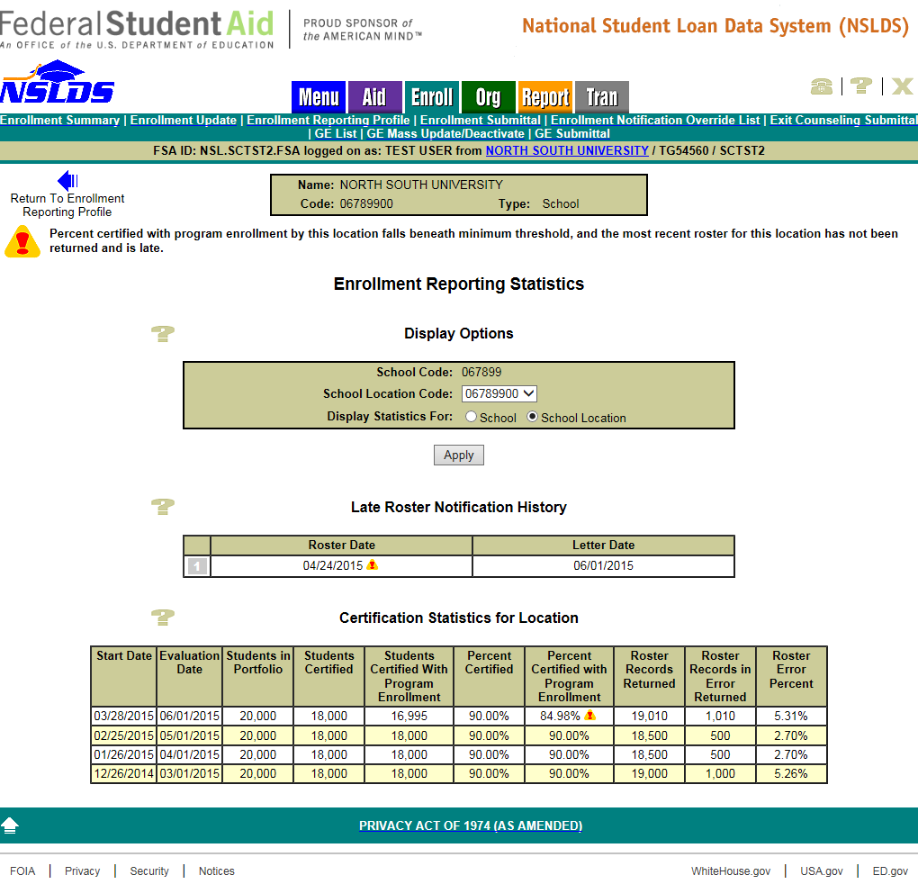

New NSLDS Enrollment Statistics Report
The new Enrollment Statistics Report (ENLST1) provides school users with Enrollment Statistics for the school code or school location code associated with the user's ID. The report includes information about completeness and quality of the enrollment reporting provided by schools participating in the federal student aid programs. The report will contain the same information that is displayed on the Enrollment Reporting Statistics page. Users may choose to receive all the data associated with the six-digit OPEID in the School Code field or specify a specific school location code by entering the eight-digit OPEID in the School Location Code field. The user selects the Evaluation Date End and the Prior Weeks in Range, and all statistics within the range will be included for the selected school location(s) in the report. The report is displayed on-demand in a browser window using MS ExcelTM format.
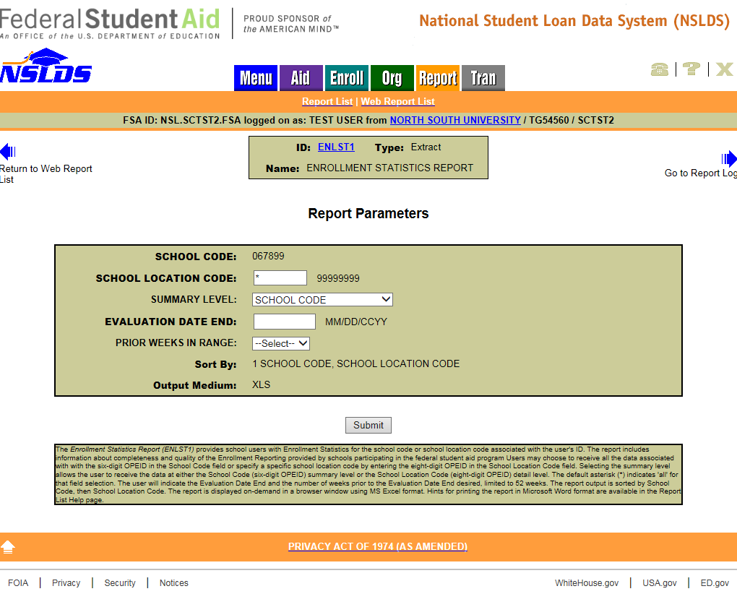
Gainful Employment
Enhancements to Social Security Number Accuracy
In an effort to assist schools with accurate Gainful Employment (GE) data reporting, changes have been applied to the Social Security Number (SSN) field. Only valid Social Security Numbers will be accepted, based on the criteria below:
- SSN must be a valid SSN as provided by the Social Security Administration
  - The first node of the SSN must not contain any of the following:
    - 9xx-xx-xxxx, 000-xx-xxxx, or 666-xx-xxxx
  - The second node of the SSN must not contain xxx-00-xxxx
  - The third node of the SSN must not contain xxx-xx-0000
For more information about GE reporting to NSLDS, refer to the NSLDS Gainful Employment User Guide available in the "Resources" section of the Gainful Employment Information Page on the Information for Financial Aid Professionals (IFAP) Web site.
GE Reporting Deadlines Reminder
Schools must report information on each student who received Title IV aid for enrollment in a GE program.
- Report all Title IV Students by July 31, 2015
  - Report 2008 – 2009 through 2013 – 2014 award years
  - GE Programs with Medical and Dental Residencies report 2007 – 2008 through 2013 – 2014 award years
- Report 2014 – 2015 Award Year by October 1, 2015
Customer Service Reminder
Please remember to keep your NSLDS Professional Access Web site ORG contacts current and always list at least a Primary Contact for your organization. Additionally, it is important to include a Customer Svc (Borrowers) contact as the information is displayed on the NSLDS Student Access Web site and may be viewed by borrowers and other Federal Student Aid partners.
The NSLDS Customer Support Center at 800/999-8219 is available Monday through Friday from 8 A.M. to 9 P.M. (ET). You may also contact Customer Support by e-mail at nslds@ed.gov. Callers in locations without access to 800 numbers may call 785/838-2141.

