Number 46 | June 2014

Summary | This newsletter describes recent enhancements to the National Student Loan Data System (NSLDS) and the NSLDS Professional Access and NSLDS Student Access Web sites. These changes include:  - Enhancements to support the 150% Direct Subsidized Loan Limit  - Loss of Subsidy warning icon  - Loss of Subsidy field  - Updates to enrollment reporting  - Updated NSLDS Enrollment Reporting Guide  - New NSLDS Enrollment Spreadsheet Submittal Format  - Enhancement to the Enrollment Maintenance page  - Enhancements to NSLDS reports  - School Portfolio Report  - Borrower Demographic Report  - Subsidized Usage School Report - New  - Enhancements to the NSLDS Student Access Web site  - New Direct Subsidized Loans Eligibility and Usage page  - Current Address page  - Display of subsidy status and usage on Loan Detail page  - Display of program enrollment information  - Supported Web browsers
Enhancements to Support the 150% Direct Subsidized Loan Limit | Loss of Subsidy Warning Icon  The NSLDS Professional Access Web site now displays a new warning icon for borrowers who have, because of the 150% Direct Subsidized Loan Limit, lost interest subsidy on one or more Direct Stafford Subsidized (SULA Eligible) (D0) and/or Direct Consolidation Subsidized (SULA Eligible) (D9) loans. The following icon will display on the Loan History, Grant History, Overpayment History, and Overpayment List pages. It will also display on the Student Access Interface page.  Loss of Subsidy Field  A new field called “Loss of Sub” has been added to the Loan Summary for Direct Stafford Subsidized (SULA Eligible) (D0) and Direct Consolidation Subsidized (SULA Eligible) (D9) loans. This field will only appear for loans which have lost their interest subsidy. In all other cases, this field will not appear.  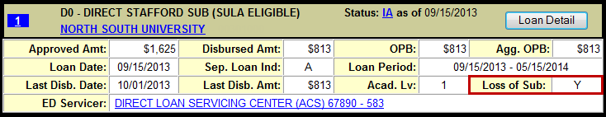
Updates to Enrollment Reporting | As we have communicated in multiple recent communications, as a result of the 150% Direct Subsidized Loan Limit schools will be required to report enrollment at the program-level no later than October 1, 2014. For more information about changes to the requirements for institutional reporting of enrollment information to NSLDS, refer to Dear Colleague Letter GEN-14-07, posted to the Information for Financial Aid Professionals (IFAP) Web site on April 14, 2014. Below we provide further information regarding notable updates and changes to NSLDS enrollment reporting.  Updated NSLDS Enrollment Reporting Guide  An updated version of the NSLDS Enrollment Reporting Guide will soon be posted on the IFAP Web site, in the NSLDS Reference Materials, NSLDS User Documentation section. The Guide has been updated to include the revised Enrollment Spreadsheet Submittal instructions, and to make minor corrections and updates. Watch for an upcoming announcement when this new version is posted.  Important Note: While we encourage schools to implement the necessary enrollment reporting changes as soon as possible, all schools must have implemented the necessary changes by October 1, 2014. Schools that choose to wait to report using the new enrollment reporting file layouts until after July 1, 2014 must, when they do begin reporting using the new enrollment reporting file layouts, report program-level enrollment information retroactive to July 1, 2014. See DCL GEN-14-07 for more information.  Reminder: Beginning July 1, 2014, NSLDS will request enrollment information from schools every 60 days and schools will be required to respond to those requests within 15 days of the date that we send the electronic enrollment reporting roster to the school (or to its designated third-party servicer). Soon we will automatically update any enrollment reporting schedules with frequencies greater than two months to the new default schedule of at least every two months. See DCL GEN-14-07 for more information.  Enhancements to the Enrollment Reporting Profile Page  The Enrollment Reporting Profile page has been updated to include an option to select one of the new enrollment reporting batch formats. Schools can select a format in which to receive the new enrollment reporting file to begin reporting program-level enrollment information, and specify the date on which this change becomes effective. Making this selection will allow NSLDS to generate a roster for the school in the new layout, allowing the school to add or update the data to an existing file. The formats available are fixed-width and comma separated values (CSV). The CSV option can be selected to generate a roster in a format that is ready to be imported into the new Enrollment Spreadsheet Submittal Format.  Should no option be selected, your enrollment roster will continue to be generated in the current enrollment reporting layout, which does not include the fields necessary to report program-level information.  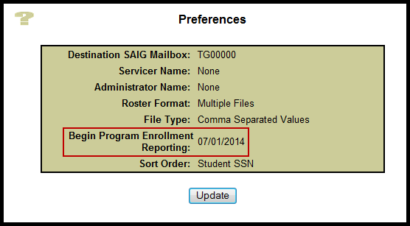  New NSLDS Enrollment Spreadsheet Submittal Format  A new Enrollment Spreadsheet Submittal Format and new Enrollment Spreadsheet Submittal Instruction Guide have been created to allow schools to report enrollment at the program-level and to provide e-mail addresses for students. Both the new Enrollment Spreadsheet Submittal Instruction Guide and the new Enrollment Spreadsheet Submittal Format will soon be posted to the "Software and Associated Documents" section of the Federal Student Aid Download (FSAdownload) Web site. Watch for an upcoming communication announcing this new functionality.  Schools must begin using the New NSLDS Enrollment Spreadsheet Submittal Format or one of the new enrollment reporting file layouts, and begin reporting program-level enrollment information, by October 1, 2014.  Enhancement to the Enrollment Maintenance Page  The Enrollment Maintenance page has been updated to pre-populate the OPEID and the student’s identifiers when adding a student to a roster when accessed using the Enrollment Summary page. If the student is not currently on the school’s enrollment roster, the remaining enrollment fields may be populated and the record submitted to be added to the school's roster. This functionality is only available when the Enrollment Maintenance page is accessed from the Enrollment Summary page.  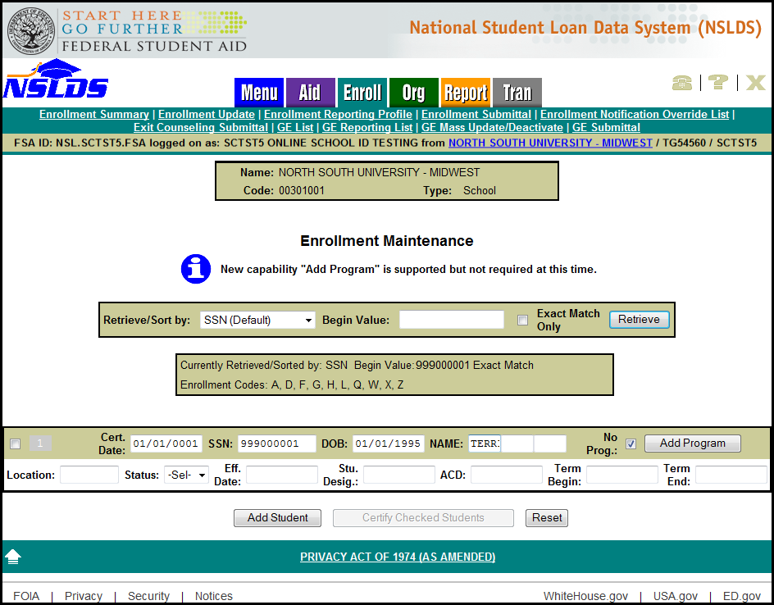
Enhancements to NSLDS Reports | School Portfolio Report – Updated  The School Portfolio Report (SCHPR1) has been updated to provide schools with information about a student’s subsidized loan subsidy status and subsidized usage period. The following data elements have been added to the record layout:  - Confirmed Loan Subsidy Status—A field indicating the confirmed status of the interest subsidy on a loan. This field is located in the Detail Record, position 543.  - L = Lost Subsidy  - R = Reinstated Subsidy  - N = For D0 loans, the loan still has interest subsidy. For all other loans this field is not applicable.  - Loan-Level Subsidized Usage Period (SUP)—The period of time, expressed in years or portions of years, for which the student received the Direct Subsidized Loan. There is an implied decimal point between the third and fourth digits. This field is located in the Detail Record, position 544 to 549.  Borrower Demographic Report – Updated  The Borrower Demographic Report (SCHBR1) has been enhanced to include the Common Origination and Disbursement (COD) System as a source of the information reported to NSLDS. This addition to the report is identified with the source value of DLORGN in the record types 05, 10, 15, and 20 as applicable. There is no position change required to receive this new information. Note that we are not posting a revised file layout for this additional source value, as it does not affect the layout itself.  Subsidized Usage School Report – New!  The new Subsidized Usage School Report (SCHSB1) provides school users with a list of student borrowers who have Direct Stafford Subsidized (SULA Eligible) (D0) loans, currently in attendance at the location of the user requesting the report. This report also includes information about a borrower’s total subsidized usage, the borrower’s loan-level subsidized usage, and the borrower’s program enrollment information. School users can request the report on the NSLDS Professional Access Web site under the Report tab. The report is sent as a fixed-width extract and delivered under message class SUBRPTOP to the Student Aid Internet Gateway (SAIG) mailbox of the user requesting the report.  File layouts for these reports are now available in the NSLDS Record Layouts section of the IFAP Web site.
Enhancements to the NSLDS Student Access Web Site | New Direct Subsidized Loans Eligibility and Usage Page  A “Subsidized Usage” button has been added under the Financial Aid Review page on the NSLDS Student Access Web site. The button will take the student to a new page, which displays information about the 150% Direct Subsidized Loan Limit and program in which the student is enrolled, as reported to NSLDS.  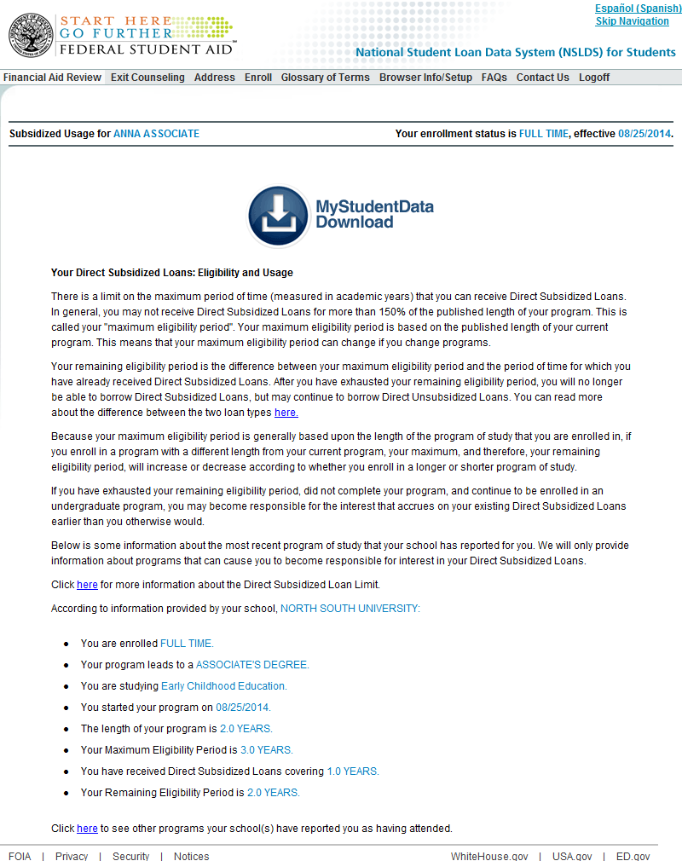  Current Address Page  The Address page on the NSLDS Student Access Web site has been updated to allow students to report their current e-mail address and phone numbers, in addition to the student’s postal mailing address.
Display of Subsidy Status and Usage on Loan Detail Page
The Loan Detail page on the NSLDS Student Access Web site has been updated to include Confirmed Subsidy Status and Subsidized Usage information for D0 - Direct Stafford Subsidized (SULA Eligible) loans as reported to NSLDS.
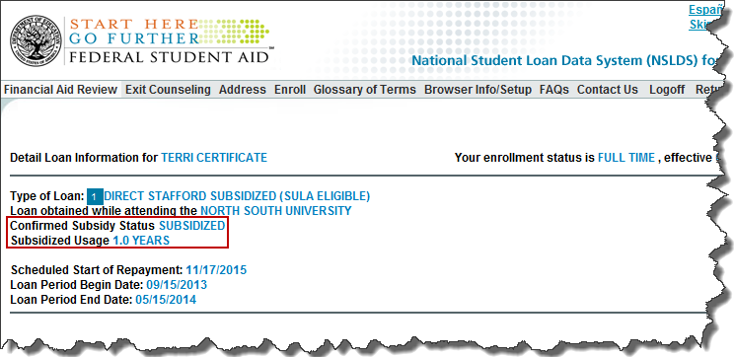
Display of Program Enrollment Information
The Enroll page on the NSLDS Student Access Web site has been updated to include information about the program(s) for which the student is enrolled as reported by a school to NSLDS.
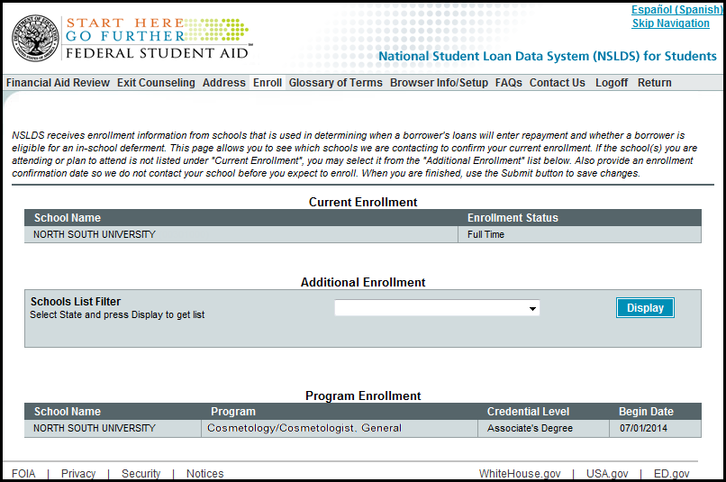
Supported Web Browsers | We recommend that users of the NSLDS Professional Access Web site use the supported browser Microsoft Internet Explorer (IE) Version 7 or lower. If you do not have this browser, it is recommended that you download it or select compatibility mode if you are using a browser greater than IE7. To provide a higher level of security, we recommend that you use a version of IE that supports 128-bit encryption. Some unsupported browsers may not be compatible with all features of the NSLDS Professional Access Web site.
Customer Service Reminder | Please remember to keep your NSLDS Professional Access Web site ORG contacts current and always list at least a Primary Contact for your organization. Additionally, it is important to include a Customer Svc (Borrowers) contact as the information is displayed on the NSLDS Student Access Web site and may be viewed by borrowers and other Federal Student Aid partners.  The NSLDS Customer Support Center at 800/999-8219 is available Monday through Friday from 8 A.M. to 9 P.M. (ET). You may also contact Customer Support by e-mail at nslds@ed.gov. Callers in locations without access to 800 numbers may call 785/838-2141.

